James Cambell Primary Teaching and Learning Policy

Approved by: | Mr Joe Wilson | Date: 14/03/2023
Last reviewed on: | 14/03/2023
Next review due by: | Autumn 2023

Contents
1. AIMS OF THE POLICY………………………………………………………………………………………………………………………….. 2. SCHOOL VISION AND VALUES……………………………………………………………………………………………………………..
- OUR CURRICULUM……………………………………………………………………………………………………………………………..
- OUR APPROACH TO TEACHING AND LEARNING………………………………………………………………………………....
- MATHS………………………………………………………………………………………………………………………………………………..
- ENGLISH FOR KS1 AND KS2…………………………………………………………………………………………………………………
- WIDER CURRICULUM AND SCIENCE FOR KS1 & KS2…………………………………………………………………………… 8. LEARNING ENVIRONMENT IN KS1 & KS2…………………………………………………………………………………………….
- EYFS……………………………………………………………………………………………………………………………………………………
- INCLUSIVE TEACHING………………………………………………………………………………………………………………………… 11. HOMEWORK………………………………………………………………………………………………………………………………………
12. LINKED POLICES………………………………………………………………………………………………………………………………….

Appendices
- Appendix 1: THE LESSON CYCLE - PRINCIPLES OF INSTRUCTION…………………………………………………………..
- Appendix 2: USING THE PRINCIPLES OF INSTRUCTION TO PLAN………………………………………………………….. • Appendix 3: RUBRICS……………………………………………………………………………………………………………………………
- Appendix 4: WORKING WALLS…………………………………………………………………………………………………………….. • Appendix 5: BOOK CORNERS

1. Aims
The quality of teaching and learning is the most important factor in the success of our children. At James Cambell Primary School, we are committed to high quality teaching and learning to raise the standards for all children. The purpose of this policy is to set out the expectations for teaching and learning at the school.

Our aim is to enable our pupils to be resilient, independent, responsible learners who have the confidence, skills and attitudes to be successful life-long achievers. We aim to promote a learning culture so that pupils attain a love of learning and the desire to continue to learn. We aim to give our pupils every opportunity to succeed.

Through this policy we aim to promote best practice, and to establish consistency across the whole school. To ensure consistency and rigour in our approach, all staff should have high expectations of themselves, other adults and the children. We aim to ensure that all children are provided with high quality learning experiences that lead to a consistently high level of pupil achievement and attitude.

2. School Vision and Values
At James Cambell Primary School, every child is given the opportunity to learn, grow and develop into respectful, resourceful and resilient citizens of the future. We actively involve all stakeholders and hold each to account, ensuring our pupils receive a high quality education.
To achieve this, we are committed to:
- Providing a calm and effective working environment, in which each child can produce his or her best work;
- Providing excellent quality teaching and learning, with high expectations that challenge and motivate every child and ensure that they reach their full potential.
- Providing a range of educational experiences through a broad, creative and enjoyable curriculum which is tailored to the needs of the children;
- Providing a welcoming environment, in which courtesy, kindness and respect are fostered;
- Providing positive role models;
- Providing a fair and disciplined environment, in line with the school’s behaviour policy;
- Developing and safeguarding the wider needs of every child- social, emotional and physical so that they are ready to be successful and resilient individuals.
- Developing links with all stakeholders and the wider community;
- Valuing and celebrating pupils’ success and achievements;
- Providing high quality professional develop for our staff within a culture of continuous improvement.

Our values are fundamental beliefs that guide and motivate our attitudes and actions. Our values describe the personal qualities we choose to embody to guide our actions; the sort of person we want to be; the manner in which we treat ourselves and others, and our interaction with the world around us. Our vision is based on six core values which underpin our ethos and curriculum.

Respect | Honesty | Responsibility | Equality | Resilience
We teach our children to respect everyone within our school community and to celebrate individual differences. We want our children to treat each other as they wish to be treated. | We teach our children right from wrong. This value also means that our children should strive to show integrity and truthfulness. Honesty also involves being trustworthy, loyal, fair and sincere. | We teach our children the things we are supposed to do and accepting the positive or negative outcome of our actions. Being responsible means, you do the things you are expected to do and accept the consequences of your actions | We teach our children that people have the same rights and opportunities regardless of what they look like or where they come from.  We ensure our pupils are equipped with the skills and knowledge they deserve to have social equity, empowering them to shape their own futures. | We teach our children to overcome barriers, disadvantage or difficulty. Resilience means knowing how to cope in spite of setbacks, or barriers, or limited resources. Resilience is a measure of how much you want something and how much you are willing, and able, to overcome obstacles to get it.

3. Our Curriculum
Teachers are responsible for maintaining secure subject and pedagogical knowledge and for ensuring the best possible learning opportunities are planned, delivered and monitored. All adults are expected to be leaders of learning, attending courses, observing good practice, building and disseminating knowledge and best practice. We use the objectives from the National Curriculum and strategies for English and maths to underpin the taught curriculum. English is at the heart of our curriculum. Teachers plan lessons using national frameworks to ensure pupils receive their entitlement. Teachers may use schemes of work as a starting point but are expected to add their own creative ideas and adapt them so that they meet the needs of the children within their classes. Wherever possible, links are made to real life experiences to make the curriculum relevant. Links are made between areas of the curriculum with non-fiction reading and writing being taught through cross curricular links. We aim to make the curriculum reflective of, and responsive to the cultural background of our pupils. Work given to the pupils across the curriculum is consistently of a high quality. We aim for pupils to achieve well consistently in all subjects, both overall and in key groups, including disadvantaged and pupils with SEND. All teachers should have a firm and common understanding of the school’s curriculum intent and what it means for their practice.

Intent:
At James Cambell, our children and their success, well-being and ambition is our priority, as well as the outcomes they achieve at the end of each key stage. We aim to develop pupils’ character, a set of positive traits, dispositions and virtues that informs their motivation and guides their conduct and thoughts so that they reflect wisely, learn eagerly, behave with integrity and co-operate consistently with others.

To achieve this James Cambell Primary School intends to:
- Provide children with the best possible start to the beginning of their learning journey through school life.
- Provide all pupils with a full curriculum with a broad range of subjects.
- Construct a curriculum that is ambitious and designed to give pupils, particularly disadvantaged pupils and including pupils with SEND, the knowledge and cultural capital they need to succeed.
- Develop a curriculum that is successfully adapted and ambitious to meet the needs of all pupils in order to develop their knowledge, skills and abilities to apply what they are able to do.
- Develop a love of reading and learning from an early age.
- Fulfil the potential of each and every child.
- Provide a curriculum that is coherently planned and sequenced.
- Provide contextual learning and enrichment opportunities with external visitors and visits.
- Ensure pupils reach clearly defined end points at the end of each phase, in line with national priorities.
- Ensure our curriculum enables pupils to transfer key knowledge to long term memory.

Our curriculum embeds and extends knowledge with personalised learning based on the interests of our children and the needs of our school community. It is designed and structured with the National Curriculum and ensures

the development of knowledge across and within all phases. Based on books, stories and quality texts, the curriculum is built to develop a love of reading and learning from an early age.

Good parenting and high quality learning together provide the foundation children need to make the most of their abilities and talents as they grow up. We work closely with parents to develop their skills, and by doing so, their ability to support their children’s learning.

At James Cambell, we aim to promote curiosity and a love of learning. To achieve this, we:

- Develop a love of reading and learning from an early age
- Develop skills in reading, writing and mathematics across all curriculum areas
- Enhance our pupils’ strengths
- Expose pupils to new experiences and give them new depths of knowledge and cultural capital.
- Recognise the unique learning needs of each pupil and to offer a bespoke curriculum that supports, scaffolds and challenges each pupil
- Offer a broad and enriched curriculum

- Offer educational visits outside the school and visitors to the school that complement and enhance the learning in the classrooms
- Develop a wide knowledge base with opportunities for depth of understanding
- Prepare children for the next year stage in their education

Cultural Capital
At James Cambell Primary, the development of children’s cultural capital is embedded in everyday practice. We keep the development of children’s cultural capital at the heart of our curriculum development and ensure that children are provided with opportunities to develop their knowledge and understanding of the world and cultures around them.

We achieve this by:
- Providing families an extensive transition program in order to get to know our families personally.
- By developing links with the local feeder nurseries.
- Providing children with rich beyond-school experiences which expose them to awe and wonder.
- Using texts which promote the development of inclusion, diversity and British values.
- Having a broad curriculum which provides children with a wide range of knowledge.
Implementation:

It is our aim that our Primary Curriculum is delivered in the following ways:
- The work given to pupils, over time and across the school, consistently matches the aims of the curriculum. It is coherently planned and sequenced towards a combination of sufficient knowledge and skills for future learning and employment.
- Knowledge and skills are structured and sequenced across the phases.
- Work given to pupils is demanding and clearly matches the aims of the curriculum.
- Teachers have good subject knowledge and are well supported by leaders and through high quality professional development.
- All teachers present subject matter clearly, promoting appropriate discussion about the subject matter being taught and systematically check pupils’ understand, identify misconceptions and provide clear feedback. In doing this, teachers respond and adapt their teaching appropriately.
- Children are always at the heart of how our curriculum is designed in order to support and develop them holistically; learning, wellbeing, socially and emotionally
- Teachers combine expert knowledge with effective teaching in order to transfer key knowledge and skills to long term memory.
- We aim to deliver a curriculum which is enriched by experiences outside of the classroom, in the wider environment and in the local community in order to fill cultural capital gaps.
- Teaching is designed to help pupils remember long term the content they have been taught and to integrate new knowledge into larger areas.
- Assessment is used to help pupils embed and use knowledge fluently and/or to check understanding and inform teaching and planning.
- All teachers create an environment that focuses on pupils and all materials used clearly support the intent of our clearly coherently planned curriculum.
- A rigorous and sequential approach to reading is implemented and at all stages reading is assessed and gaps are quickly addressed.
- A sharp focus on ensuring children gain phonic knowledge and language comprehension necessary to read in order to give them secure foundations for future learning.
- Teachers ensure that they are emulating speaking, listening, writing and reading of English appropriately in order to support pupils in developing their language and vocabulary.
- Pupils with SEND have clear targets setting out the next steps in their learning and development.

Impact:

The impact of the quality of education at James Cambell Primary School is assessed continuously through discussions between subject leaders and teachers to ensure that our curriculum intentions are leading to good results and good progress for all groups of pupils, preparing them well for the next stage in their education. A robust assessment system is in place for English, maths and the wider curriculum subjects as pupils develop detailed knowledge and skills. Our curriculum also has a greater emphasis on the behaviour and attitudes of children towards their learning.

As children progress through each year, they further develop key skills and ideas about how to be well prepared for learning and how to meet their next steps and targets. They are taught to have a positive mindset and show teamwork and resilience. Teachers use assessment for learning and assessment of learning strategies to understand and support the children to achieve their highest potential. Teachers use positive praise and give regular feedback to children, both oral and written, on how to improve their subject knowledge, skills and learning habits.
Through learning walks, lesson observations, book scrutiny, feedback from teachers and children and the analysis of data, leaders ensure planning is well differentiated and the curriculum is accessible to all children they teach, ensuring high standards of presentation and acquisition of skills and knowledge. At James Cambell Primary we ensure that:
- Pupils develop good/detailed knowledge and skills across the curriculum and so achieve well and this is reflected in national tests.
- All pupils are ready for the next stages in their education, and have the skills and knowledge required.
- Pupils with SEND achieve the best possible outcomes.
- All pupils’ work across the curriculum is of a good standard.
- Pupils read for pleasure, read widely and often, with fluency and comprehension skills appropriate to their age.
- Pupils are able to apply mathematical knowledge, concepts and procedures appropriate for their age.
➢

4. Our Approach to Teaching and Learning

At James Cambell Primary School we are committed to the highest standards of teaching and learning and we are relentless in our desire to continually raise standards. We recognise the importance of creating a climate in which children can learn effectively and we believe that consistent teaching and behaviour management strategies are key to this. As a result, all staff should embrace the five core principles and must:

- Know the purpose of every activity and share it with children, so children know the one thing they should be thinking about.
- Be passionate about teaching so they can engage children emotionally.
- Teach at an effective pace and devote every moment to teaching and learning.
- Ensure that every child participates throughout the lesson. Partner and teamwork is fundamental to learning.
- Praise effort and progress – not ability.

We have designed our curriculum to encourage independence and resilience by promoting the following:

- making decisions ➢ a ‘growth mindset’ and self –

- problem solving motivation
- perseverance ➢ communication
- teamwork ➢ articulating thinking
- building on knowledge and ➢ learning from mistakes skills ➢ evaluation
- making connections ➢ reflection

- metacognition

Mastery

At James Cambell Primary School, we are committed to the mastery approach to teaching and learning.
The mastery approach involves breaking down larger, complex learning goals into smaller, more granular steps. Mastery is an inclusive way of teaching that is grounded in the belief that all pupils can achieve. Teaching methods are aimed at encouraging pupils to have a more intuitive understanding of concepts, starting with a broader concept and then breaking the problem down into specific steps. A concept is deemed mastered when learners can represent it in multiple ways, can communicate solutions using appropriate language and can independently apply the concept in different contexts.

When students find themselves in an achievement situation, they will often be given set goals that give direction to their efforts and act as frameworks, helping teachers to understand how individuals perceive, interpret, and react to achievement situations. When mastery goals are met, a pupil’s satisfaction isn’t related to external indicators. This means they are less likely to give up in the face of difficulties or obstacles, and will be more inclined to persevere through setbacks. Mastery goals are always ‘just beyond reach’. This makes motivation over the long term easier to maintain, as there is always something better to strive for. The pitch of lessons is always at a high level with appropriate scaffolding and support.

Grouping
When using the mastery approach pupils are not broken into separate groups depending on their perceived intellectual abilities. Instead, all pupils perform the same work at the same time, with appropriate scaffolding, before mastering and advancing to the next concept together.

Children at James Cambell are predominantly taught in mixed-ability groups. However, we recognise that there are some children who require additional support to address significant prior gaps in their learning, and this can sometimes be most effectively delivered in a separate group whether for English or maths. In addition, phonics is taught in assessed groups.

Decisions on whether grouping is appropriate in a particular year group is taken on a case-by-case basis and follow the structure and principles below:
- Limits are not set on pupils to succeed. The mastery approach is used in all groups, and high expectations maintained of all children’s progress.
- Children’s progress is monitored and compared on a regular basis in line with the assessment cycle. If the gap is widening, then appropriate action needs to be taken (whether through movement between groups, providing additional or different support or reconsidering the appropriateness of a separate group).
- Particular attention is given to the needs of disadvantaged children and children with SEND.
- Pupils are not assigned to a particular group on the basis of behaviour.

When grouping children, consideration is also given to providing:
- A good mix of positive role models;
- Some quieter children, some more outspoken;
- A good mix of girls and boys;
- Some children who are more confident to try a challenge, some who sometimes struggle.

Features of Teaching

Teaching at James Cambell will demonstrate the following features in all lessons¹:

- Recall Checks – at the start of every lesson to activate prior learning and identify any areas that need to be recapped. This could be in the form of a quiz, a problem similar to the previous lesson or partner talk explaining the previous lesson’s learning.
- A clear learning objective (LO) and success criteria (SC) for every lesson. The LO is the skill or the knowledge that you plan for your pupils to acquire during the lesson. Success criteria are measurable and specific, and can be used to assess whether an LO has been achieved. These are shared with and explained to the children.
- From September 2021, rubrics to be stuck into the children’s books at the start of each lesson showing the LO and SC (see Appendix 2).
- Learning Objective and Success Criteria to be displayed throughout the whole lesson.
- High quality modelling by the teacher – providing children with the cognitive support through modelling, worked examples and teacher thinking out loud to clarify the steps in their learning.

¹ There will be a few lessons, such as PE, where not all of these features are applicable.

- Encouragement of engagement from all children by consistent use of talk partners and group discussion, accompanied by the use of a random reporting system (e.g. lolly sticks or name fans).
- Open-ended questioning (Bloom’s taxonomy is helpful for this), using a range of techniques, to establish how well material is being learned.
- Encouragement of resilience and a growth mind-set, helping children to develop a ‘can do’ attitude, staying positive and learning from their mistakes.
- High expectations – always pitching learning high and in line with the year group’s National Curriculum requirements, while providing appropriate scaffolding and support as appropriate.
- Scaffolding for tasks – initially this may be for the whole class rather than specifically to support children with SEND and low attainers. Scaffolding (differentiated support) can take a wide range of forms, such as adult support and intervention, peer working, word banks, checklists (including the SC), visualisation, repetition, resources, classroom layout, pre-teaching and post-teaching. Scaffolding is gradually withdrawn as children gain confidence.
- Expectation that children transition quickly and quietly between activities.
- Oral feedback during the lesson, combined with focus/peer/self-marking in books, which is specific, clear and accurate. This will consolidate learning, give specific praise, address misconceptions and provide clarity on next steps (as set out in the Feedback Policy).
- Adapting the teaching from the plan or scheme of work to ensure that, throughout the lesson, the children are:
- Inspired, engaged and motivated
- Challenged and making good progress
- Keen to contribute, asking relevant questions and debating the topic with enthusiasm
- Interacting productively with each other as well as the teacher
- Able to articulate what they are doing and why and how this relates back to prior knowledge
- Where necessary, re-taught prior knowledge
- Proud of their achievements during the lesson

- Clear plenary at end of lesson to review and reflect on learning – have the LO and SC been met?
- High expectations of presentation in all books from the front sleeve to the back page.

The following features will be demonstrated in most lessons (as appropriate):
- ‘Do now’ activity for the start of every lesson - an activity on the board or on the pupils’ tables for them to do independently as soon as they enter the classroom. At the start of the day, work to be completed in ‘morning books’.
- Starter: a ‘hook’ to engage and excite the learners.
- Presentation of new material in small steps to avoid cognitive overload, allowing time for practice so that it can be mastered.
- Guided practice (whether individually, in pairs or groups) with the teacher close to ensure that children are building confidence and not making too many mistakes.
- The opportunity for independent practice (this will sometimes include the opportunity for children to apply the knowledge to real-life situations). Children need lots of opportunity for practice in order for skills to become embedded and automatic.
- Teacher modelling to be displayed on working walls.
- Mini-plenaries during independent practice – to check children’s understanding, consolidate learning and provide opportunities to address misconceptions.
- The promotion of metacognitive practice – encouraging children to be active and independent agents in their own learning, providing them with the opportunity to plan, monitor and evaluate their learning (a feature which increases as the children become older). For example, encouraging use of the ‘5 Bs’ (brain, book, board, buddy, boss).

A sequence of lessons will follow the pattern of ASSESS, PLAN, TEACH, REPEAT.

If a high success rate has not been obtained (i.e. achievement of the Learning Objective), then the teacher will look at re-teaching that concept in a following lesson, reflecting on how the material could be presented in a different way. Forgetting is a natural part of learning so opportunities for regular review – weekly and monthly – will be built into the curriculum.

These features draw on the educational research of Barak Rosenshine in his principles of instruction (see Appendix 1), which themselves are based on a wide range of research into education and cognitive science, as well as observations of effective classroom practice.

5. Maths

At The James Cambell Primary our aim is to develop lifelong mathematicians who are curious and creative. With a firm foundation of mathematical fluency, we want pupils to recognise the importance of having a deep understanding which is achieved by investigating and exploring mathematical concepts. Fostering a growth mathematical mind-set is key to this as pupils become resilient and resourceful in their mathematical journey.

At James Cambell Primary, we are building a culture of deeper understanding, confidence and competence in maths – a culture that produces strong, secure learning and real progress. No matter what their starting points, we strive to ensure pupils achieve excellence through a mastery approach to teaching. We do this by using the White Rose maths scheme in Years 5 and 6, and Power Maths in Reception to year 4
Features of a Maths lesson
At James Cambell, we follow the maths mastery approach. The structure of the maths lesson should include the following elements:
- Pupils being taught as a whole class on the same content; we do not accelerate children to new content, but broaden and deepen their understanding of the current content through variation so that it is mastered. Children are taught in mixed ability groups with appropriate scaffolding.
- High expectations – always pitching learning high and in line with the year group’s National Curriculum requirements, while providing appropriate scaffolding and support as appropriate.
- A high-level of teacher-student and student-student interaction where all students in the class are thinking about, working on and discussing the same mathematical content. We highly value mathematical talk and precise mathematical vocabulary, during both conversations and written work, and the expectation is that children answer in full sentences.
- Differentiation through paying close attention to the levels of support and challenge needed to allow every student to fully grasp the concepts and ideas being studied.
- Well thought out resources to support learning – e.g. some may use number lines, other may use mental images
- Peer support – from learning partners
- Ongoing use of AFL throughout the lesson, often referred to as responsive or diagnostic teaching. This allows teachers to identify pupils who have not grasped a concept immediately and offer an alternative model/ representation or alternative explanation. This may be during whole class teaching or in a guided group or during intervention outside of the mathematics lesson.
- Mini-plenaries used throughout learning – to assess progress and provide opportunities to address misconceptions.
- Self and peer marking - as a way of allowing pupils to receive instant feedback on their learning and providing ongoing AFL.
- Reasoning opportunities and mathematical thinking embedded throughout the lesson. Children are expected to not only answer the question but also to explain how they came to the answer using a green pen. Challenge and the opportunity to deepen understanding of the key mathematical ideas provided for all.
- Use of CPA approach, including manipulatives, multiple representations and bar models, to develop deeper understanding.
- Daily arithmetic sessions focusing on issues arising from gap analyses. In KS2 10 timed questions per day covering the four operations; KS1 have five questions. A weekly times table test is set on Monday and tested on a Friday. The results are sent home to parents.
- Use of higher order questioning to stimulate mathematical thinking, discover patterns and connections, explain reasoning and make generalisations;
- Immediate feedback given to children’s work and opportunities for clarification/ intervention set as quickly as possible
- Time to practise a new skill until children become fluent.
- Evidence of the learning journey and critical thinking in books – for example through the use of jottings
and responding to feedback from the teacher in green pen.
- Encouragement of independence – for example through use of self-assessment, talk partners, accessing information on working walls and open-ended extension tasks.
- A clear learning objective (LO) and success criteria (SC) for every lesson.
- High quality modelling by the teacher and put on the working walls.
- High expectations of behaviour for leaning.
- Clear plenary at end of lesson to review and reflect on learning.
- Response to teacher’s marking in green pen.

Maths Assessment in KS1 and KS2
In addition to the ongoing teacher formative assessment, each term teachers use a formal assessment test (such as a previous SATs paper or PUMA). Staff will use the outcome of those tests, including gap analyses where appropriate, to inform future planning and lessons. These assessments will be used as part of pupil progress meetings and to feedback to SLT and parents as required. In years 2 and 6, SATs tests will also be used.
If a child cannot access the year group expected assessments, then another assessment should be agreed in advance with the SENCo and maths subject leader.
Year 4 will sit the statutory multiplication tables check. Progress on times tables in years 3 and 4 will be tracked half-termly.
Expectations in Maths books for KS1 and KS2
- From September 2021, presentation policies stuck on the front page (cardboard) of every book.
- From September 2021, rubrics stuck in books to show LO and SC ➢ Use a squared book
- Always use a sharp pencil.
- Always use a ruler to draw straight lines and underline in pencil.
- Always present your work neatly.
- Always write one digit in each box.
- Always use a green pen to peer assess and respond to marking. ➢ Always write the short date on the right-hand side.
- In KS2 the date should be written in roman numerals
- Always miss a line after the date and write the learning objective.
- Always underline the date and LO.
- Always miss a line after the LO and between each question.
- Stick rubrics in carefully and neatly.
- Always start a new piece of work on a new page. ➢ Do not write across onto the opposite page.
- Worksheets must be trimmed and glued neatly
- Presentation on worksheets must be as neat as in your book.
- If a mistake is made, use a ruler and a pencil to draw one small line through it.

6. English

In a world where the fundamentals of reading and writing lay the foundations of all learning, we believe that English should be at the heart of all aspects of school life. Therefore, at James Cambell we aim to deliver an exciting, ambitious and innovative English curriculum that enables and empowers our pupils to become enthusiastic and successful readers and writers, with a deep love and understanding of the English language. We believe the sequential development of reading, writing, grammar, punctuation and spelling (GPS) and communication skills are key for academic success and lifelong learning.

At James Cambell, we have a structured, cohesive and co-ordinated approach to the teaching of writing, grammar, reading and comprehension. We teach English using a range of strategies including:
- Group Discussion – Children discuss and explore new ideas in a small group or whole class setting.
- Partner Talk – Children work in partners to discuss their ideas. They are able to explain their ideas about texts they have read inform their writing, language choices and organisation features.
- Questioning – Teachers use a range of questioning strategies to establish children’s current understanding and develop their learning. Higher level questioning is used to elicit a deeper understanding and analyse composition choices, such as vocabulary, grammar and structure.

- Modelled Writing – Teachers model writing and editing to demonstrate the high expectations they have. They verbally ‘think aloud’ in order to make the writing process explicit and provide a rich and varied vocabulary for the children to utilise in their own work.
- Shared Writing (guided practice) – Teachers use the ideas from the children to create shared pieces of writing. This enables the children to see the writing process in action as well as having pride and ownership over the finished piece.
- Comparing, Analysing and Evaluating – Children review written texts, speech and drama and compare, analyse and evaluate them. They establish the strengths and weaknesses of different examples and incorporate these ideas into their own work.

Writing
The week contains five lessons that are designed to develop children’s writing composition, in addition to teaching grammar, vocabulary development, critical thinking and spoken language. English lessons are planned in reference to Read Write Inc (EYFS and KS1) and Literacy and Language (KS2), with all work recorded in books.
The programme of study at James Cambell consist of:
- Writing – children acquire, develop and broaden composition skills
- Grammar – children acquire and apply grammatical skills to develop into skilled writers and evaluators
- Phonics – children have daily lessons in the Early Years and in year 1 (with additional phonics lessons in other years where required) following the structured approach of RWI.
- Handwriting – taught explicitly 3 times a week through morning sessions following the Nelson Handwriting scheme.
- Spoken Language – children to develop spoken language through discussion and consider ideas through partner work, small groups and whole class setting.

Reading KS1
In Reception, children do independent reading. In year 1, children are taught reading and writing through RWI. In Year 2, guided reading is taught through a carousel method, which is used to ensure key reading skills are consolidated and understood. Guided reading, or 'guiding comprehension', is one of the most powerful teaching tools we use to meet higher standards of reading. Teaching reading in this way gives teachers the opportunity to work closely with pupils, tailoring the teaching and the level of the text to their needs.
Key reading skills will include:
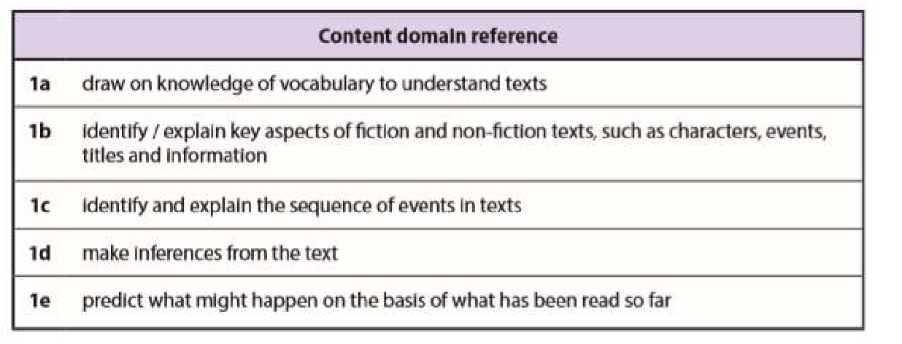
- Decoding
- Reading for meaning
- Contextual language
- Literal questions
- Simple inference
- Prediction

Reading KS2
In KS2 we use ‘Destination Reader’, which is a reading approach which can dramatically improve pupil’s reading, whilst making sure no pupils are left behind. By developing a deeper understanding of what’s being read, Destination Reader actively engenders a love of reading. This scheme helps teachers improve their effectiveness in the teaching of reading through the use of proven techniques involving language stems and other strategies. The approach involves daily sessions incorporating whole class modelling, partner work and independent reading to deliver structured daily reading sessions at KS2. The programme encompasses the key principles of effective reading provision and fully meets the requirements of the National Curriculum.
The key features of Destination Reader are:
- Independent learning based on learning behaviours / partner work
- Direct teaching of reading (15 minutes) to whole class before independent reading session (30mins)
- Focus on talk – partner work, discussion and explanation
- Reading walls support learning in reading
- Increased school responsibility on consistent approach to ‘reading for pleasure’

- Focus on teaching of key strategies which enable a deeper understanding of texts
- Focus on reading a range of high quality fiction, non-fiction and poetry
- A formative approach to assessment placing children at the heart of their learning.

The Destination Reader approach covers seven key skills identified within the national curriculum to support the reading and understanding of a wide range of texts. These are:
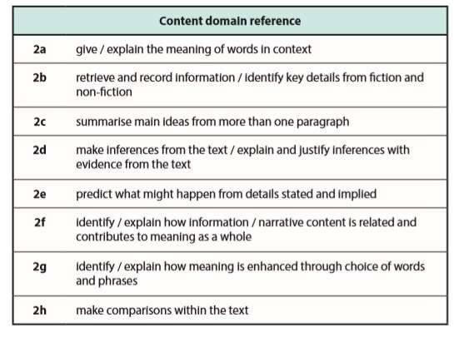
- Predicting.
- Making connections.
- Asking questions.
- Evaluating.
- Inferring.
- Summarising.
- Clarifying.

A rich book-based curriculum is used within literacy lessons. A book-based curriculum can have a dramatic effect upon children’s outcomes and levels of engagement. It is extremely beneficial in broadening children’s literary repertoire by exposing them to a range of beautiful and important literature as well as a range of significant authors and poets. Books also create the perfect context for purposeful writing to take place, and we can create immersive experiences for children that provide a platform for learning. Books ask more questions than give answers, and this creates critical readers and thinkers. This type of curriculum also creates opportunities for children to develop empathy by relating to characters and exploring others’ lives and helps children to emulate the style of known authors and develop literary language and their own ‘inner voice’.

Vocabulary
Vocabulary acquisition, and application is a focus within James Cambell Primary School because vocabulary is a strong indicator of reading success. We know from research that the size of a child’s vocabulary is the best predictor of success in the future. We also know that a good understanding of a wide range of vocabulary supports success across the whole national curriculum. Therefore pupils are regularly taught new vocabulary in all areas of the curriculum.
Developing vocabulary occurs in two ways:
- Through indirect instruction; using rich reading experiences to grow vocabulary ‘naturally.’ Paying attention to context to work out meaning and using background knowledge and through direct ‘robust’ instruction.
- Good vocabulary instruction involves decisions about which words to teach and decisions and expertise around how to teach these words

Words are chosen by class teachers that can be used in all areas of writing and the wider curriculum. Children contribute to these words. Vocabulary is on display at the front of the class.
From September 2021, word types are classified by colour with regards to their word type:
Verbs – Red
Adverbs – Yellow
Adjectives – Blue
Nouns – Green

Assessment- Writing
As well as ongoing formative assessment, teachers from Reception to Year 6 assess the writing of every child half termly. In Key Stage 2, writing assessments take place after each unit of fiction and non-fiction writing. All assessments are solely based on the pupil’s independent work. When a child is entitled to adult support (SEN), writing support given must be noted and passed onto the subject lead to allow for monitoring of progress. All independent writing is assessed according to National Curriculum objectives for each year group. Teachers also take into account all work completed throughout the term.

Assessment- Reading
Regular, ongoing and accurate assessment is essential to inform planning and ensure that all children make progress.
Assessment in reading is carried out in two ways:
- Word Reading: The Nelson Benchmarking system is used to accurately level a child’s reading ability for KS1 and LKS2 and Destination Reader ‘reading tracker’ to monitor UKS2.
- Written tests are carried out each term to assess comprehension (e.g. previous SATs paper and PIRA).

Expectations in English books
- From September 2021, presentation policies stuck on the front page (cardboard) of every book.
- From September 2021, rubrics stuck in books to show LO and SC.
- Always use best writing (joined in accordance with Nelson handwriting scheme).
- Blue pen must be used to write - Pencil Year 1 – 2.
- Green pen must be used to respond to marking.( red for supply) ➢ Green pen used for peer and self-assessment and editing.
- Final edited pieces of writing must be written up in best so you have a completed piece. ➢ Write the full date against the margin on the right-hand side (day, date, month and year) ➢ When starting a new paragraph, miss a line and do not indent.
- Complete the line before starting a new one.
- Worksheets must be trimmed and glued neatly into books.
- If you make a mistake use a ruler and a pencil to draw one small line through the mistake.
- Presentation on worksheets must be as neat as in books.
- Learning objective must be written on worksheets.
- Do not write across onto the opposite page.
- TAFs stuck on the back cardboard page of each book to be completed with each piece of assessed writing- 2 per half term.

7. The Wider Curriculum and Science

At James Cambell school we believe that a key role for primary education is to prepare pupils for a happy and successful later life. This means ensuring that our pupils not only learn core skills in English, maths and other curriculum subjects effectively, but also develop important ‘skills for life’ such as self-awareness, compassion, teamwork, personal organisation and leadership. Our curriculum is geared to achieving our goal of ensuring that our pupils are ‘Ready for life’.

While we have the highest of expectations for our pupils within the classroom, this is only a part of the learning experience that we offer. We believe in providing a breadth of opportunities for our pupils that will give them the best possible foundations to carry forward into the next stage of their education.
The school offers a broad, balanced and differentiated curriculum covering all areas of the National Curriculum and our aim is to provide a curriculum that meets the needs, interests and abilities of all children.

Our curriculum comprises of the core subjects – English, Mathematics and Science and the foundation subjects – Computing (ICT), Design Technology, History, Geography, Art, Music, Spanish and Physical Education. Personal, Social and Health Education is taught through our assemblies and a scheme called ‘Jigsaw’. The curriculum map is published for parents every term on the school website.

We do our utmost to maximise success for all children by giving them the best teaching and learning experiences. We use a range of teaching methods to suit the needs of the children and the subjects being taught. The core subjects are taught both stand alone and as part of our creative curriculum. We also believe that knowledge, skills and understanding have their own distinct characteristics that impact on how each is planned for, learned, taught, assessed and reported on.

Knowledge: refers to factual information. Knowledge is relatively straightforward to teach and assess (through quizzes, tests, multiple choice, etc.), even if it is not always that easy to recall. You can ask your children to research the knowledge they have to learn but you could also tell them the knowledge they need to know. Knowledge is continually changing and expanding.

Skills: refer to things children are able to do. Skills have to be learned practically and need time to be practised. Skills are also transferable and tend to be more stable than knowledge – this is true for almost all school subjects. Assessment at James Cambell is based around the assessment of children’s skills.

Understanding: refers to the development or ‘grasping’ of conceptual ideas, the ‘lightbulb’ moment that we all strive for. Understanding is always developing. None of us ever ‘gets there’, so you can’t teach or control understanding, but what James Cambell curriculum does, is allow teachers to provide a whole range of different experiences through which children’s understandings can deepen.

The process of learning

The wider curriculum (all subjects excluding English and maths) has been developed around a process (entry points, the big picture ,recording activities and exit points) which supports the ways in which children learn best from the ages of 5-12 years. It is important that children don’t just experience the structure and process, but also that they understand why they are learning in this way.

The Entry Point
The entry point is an exciting and memorable event that launches every unit of work. The aim of the entry point is to get children thinking about, and engaged with, the learning that’s to follow. The teachers then have the chance to find out what children already know about the theme and helps them to personalise the unit by finding out what children want to learn in order to tailor their lessons accordingly. It reinforces connections between existing and new learning and allows children to take ownership of their learning.
The Big Picture
Children are then presented with the ‘big picture’ of the unit before it launches so that connections between subjects and concepts can be facilitated. Each subject area has planned research, enquiry and practical activities, which are designed to make sure that children can access information in a way that is appropriate to them, drawing on a wide range of learning approaches.
Recording Activities
The recording activities enable children to process and present the information they have gained in their activities through a range of approaches which tap into their different strengths and interests and enable them to get better at other ways of recording. This might involve learning through digital recording, drama, musical compositions, maps, graphs, experiments, art work and so on.

Exit Point
The exit point completes every unit. It helps children to draw on their prior learning, reminding them of all the connections between subjects that they have made, and creates time and opportunities to build their understanding of their learning, and to reflect on this individually and as a group. The exit point is an excellent chance to engage with parents, guardians and carers and involve them in celebrating the learning that has been achieved. Assessment is a key part of the curriculum whereby staff identify opportunities within different units to make sure the children have learned what has been planned for them to learn.

Science
At James Cambell, we use the Collins Snap Science Scheme. Each year group has topics that cover the national curriculum objectives and scientific enquiry objectives. Snap Science is a comprehensive programme which enables our teachers to deliver outstanding science throughout the school.

Success Criteria:
Each curriculum subject has defined success criteria that are typed and printed for pupils to stick in their books.

8. Learning Environment

Teachers are responsible for providing a caring, supportive and stimulating learning environment in which all children are helped to reach their emotional and academic potential. Children learn best when they feel safe to take on challenges, are interested and motivated and feel valued. We recognise the importance of building positive self-esteem in children.

We believe that the essentials of positive self-esteem are:
- Belonging: each child has a contribution to make, we value and encourage these.
- Aspirations: every pupil is encouraged to work towards their achievable goal. Teachers express high aspirations for themselves and the children they teach.
- Safety: Consistency in expectations and standards help pupils feel safe. Clear boundaries are set and good behaviour recognised and rewarded.
- Identity: a sense of self knowledge is supported by the belief that individuality is not threatened by undue pressure to conform. We respect difference and encourage children to learn from and thrive within our diverse community.
- Challenge: acquiring coping strategies are an important part of development and learning. Children are taught to take risks and learn through mistakes.
- Success: teachers reinforce success and build an environment where risks can be taken. Success is celebrated as part of our learning culture.

Displays

The aim of displays is to enhance and accelerate learning and to build self-esteem and belonging. We use displays to support and reinforce learning. Displays should aid recall, stimulate further thinking, give new information, make connections, celebrate achievement, remind pupils of rules and targets and motivate pupils towards further learning. Key words and vocabulary and pictures can be used to support the learning of all children in the class, displays should be vibrant, colourful and interactive. Each pupil should have the opportunity to have work displayed in the classroom. Each class should have:

- Writing, reading, maths and science working walls (see templates at Appendix 3)
- Engaging displays of subjects across the curriculum (within space limitations) ➢ Class rules
- Attractive and comfortable book corners (see Appendix 4 for examples)
- Good to be green display
- Learning tools such as key words and questions for humanities/English/reading/maths, posters, prompts, number lines, spelling aids, punctuation pyramids, word banks etc.
- Esteem-raising well-presented displays of high quality children’s work that reflects their achievements
- Positive inspirational slogans, but only where these are relevant and incorporated into practice
- Interactive displays reflecting current topic to promote investigation and curiosity, including artefacts
- Displays that reflect the make-up of the school population i.e. positive images of culturally diverse groups, examples of community languages and images that challenge stereotypes of gender and disability
- Visual timetable on display at all times during the day using symbols where appropriate
- Communal display area providing information for parents e.g. school aims, newsletter, curriculum aims, how to help at home, important dates etc.
- Planning for the week in case the class needs to be covered

Early Years Aims

At James Cambell Primary, our principal aim is to give pupils secure foundations for later learning by building on skills they have previous learnt at home and/or pre-school. Throughout the Early Years, we work to develop key learning skills such as listening, speaking and sustained concentration. As part of this, the pupils learn to work together and to co-operate with adults and other children.
The aims of the reception and nursery team are to:
- Provide a well-planned and resourced curriculum
- Meet the emotional and educational needs of each child
- Help children learn and provide opportunities for all children to succeed ➢ Provide an atmosphere of care and of feeling valued ➢ Encourage each child to become independent.

The Foundation Stage curriculum is set out by the Government and covers seven areas of learning as follows:
Personal, Social and Emotional Development
The children are encouraged to say what they like and dislike. Through participating in a variety of activities they will become more confident when speaking in a familiar group. Children at James Cambell Primary School are always encouraged to become independent and yet to ask for help if they need it. At our school the children are valued individuals who are encouraged to respect each other and the school environment.
Communication and Language
Using stories and rhymes, we help the children to improve their listening and responding skills. It will become second nature to listen to what others have to say and to react effectively when given instructions. The pupils are always given the opportunity to speak in front of both small and large audiences and are encouraged to use past, present and future tenses accurately.
Physical Development
The pupils will be helped and supported to become very confident with their movements and will develop their control and co-ordination on a large and small scale. Safety is of huge importance and the pupils will be able to find a space of their own in which to work. The pupils will be introduced to a range of equipment for PE, cooking and constructing. They will be taught how to use these safely and efficiently.
We promote a healthy lifestyle in many ways at school. The children are made aware of, and are taught about, the importance of physical exercise, a balanced diet and other ways in which they can keep themselves healthy and safe. The children quickly become independent with regards to their personal hygiene.
Reading
The children take part in daily phonics session where they are taught the sounds of the letters and how to put them together for reading, and separate them for spelling. Tricky words are taught through learning by sight, these are sent home weekly on a Phase Sheet. Parents are encouraged to read daily with their child.

Writing
The pupils are encouraged to use the sounds that they hear in words when attempting to spell them. The children will write sentences independently and are asked to read their work with adults and peers. Some words will be spelt correctly and other words spelt using the sounds. All attempts are praised.

Mathematics
Counting to 20, ordering numbers and finding one more and one less are skills that we work on throughout the Reception Year. This will help the children when we start to add and subtract two single-digit numbers and count on and back to find the answers. The children are encouraged to solve problems and to talk about how they are finding out the answers.

The pupils will use everyday language to talk about size, weight, capacity, position, distance, time and money to compare quantities and objects and to solve problems. They will be able to recognise, create and describe patterns. They will explore characteristics of everyday objects and shapes and use mathematical language to describe them.

Understanding the World
We spend a lot of time exploring the similarities and differences between people, cultures and lifestyles. The children have the opportunity to share the things that are going on in their own lives and to learn to be sensitive to their peers.

We enjoy helping the children to find out more about their own environment and about the world in which they live. They will explore changes that might occur through the seasons and make observations of animals and plants.

Pupils are becoming more and more knowledgeable about technology and how it is used at school and in the home. They enjoy using the computers, laptops, cameras and remote control cars.

Expressive Arts and Design
Singing songs, dancing and making music is something that the pupils love to experiment with. They are taught how to safely use and explore a variety of materials, tools and techniques, experimenting with colour, design, texture, form and function.

The pupils use what they have learnt about media and materials in original ways, thinking about uses and purposes. They represent their own ideas, thoughts and feelings through design and technology, art, music, dance, role-play and stories.

9. EYFS- Learning and development:

We want pupils to be engaged in the learning process and for their learning to be relevant and purposeful. Therefore, at James Cambell, we believe that pupils learn best by doing. We believe that play, both indoors and outdoors, is essential for young children’s learning. Play helps children to explore, investigate and make sense of the world around them. Play allows pupils to be challenged in their thinking and helps them to practise and rehearse skills and to be motivated in their learning. The children at James Cambell are inquisitive and curious and we wish to build upon this in a positive and enjoyable manner.

The EYFS curriculum provides the basis for continuity of experience by clearly established links with the programmes of study for KS1. Within these areas of learning, the early learning goals establish expectations for most pupils to reach by the end of the Early Years Foundation Stage. Some pupils in our school will exceed these goals and others will still be working towards them as they enter Year 1. The areas of learning provide a basis for our planning and provision. However, we know that pupil’s learning is not divided into distinct areas. Often, one experience helps a child to develop a range of new skills and concepts across several areas of learning.

Our practitioners consider the individual needs, interests, and stages of development of each pupil, and use this information to create challenging and enjoyable experiences for them in all of areas of learning and development.

In Nursery, we focus strongly on the three prime areas as well as on developing children’s number and reading skills. The learning in Nursery provides a strong basis for children to progress well in Reception.

In Reception, there will be a greater focus on all areas of learning as children grow in confidence and ability within the three prime areas. By the end of Reception, we aim to prepare children for the demands of Year 1,

carefully considering the increased expectations of the 2014 national curriculum. We strive to secure the essential skills of reading, writing and mathematics, as the gatekeepers for successful learning across all other subjects.

Throughout Nursery and Reception, we aim to ensure that children are provided with knowledge and learning that prepares them for future employment and education. We do this by providing children with a curriculum that is progressive, well sequenced and develops children’s knowledge and understanding of the world. Our

communities are culturally and linguistically diverse. Reasonable steps are taken to ensure that opportunities are provided for children to use and develop their home language as well as providing good opportunities to develop their vocabulary and skills in English. When assessing communication, language and literacy skills, we assess children’s skills in English. If a child does not have a strong grasp of the English language, we then explore the child’s skills in the home language with parents/carers, to establish whether there is cause for concern about language delay.

Characteristics of Effective Learning

The EYFS also includes the characteristics of effective teaching and learning and the Nursery and Reception teachers plan activities with these in mind. These characteristics highlight the importance of a pupil’s attitude to learning and their ability to play, explore and think critically about the world around them. The three characteristics are:

- Playing and Exploring – children investigate and experience things, and ‘have a go’.
- Active Learning – children concentrate and keep on trying if they encounter difficulties, and enjoy achievements.
- Creating and Thinking Critically – children have and develop their own ideas, make links between ideas, and develop strategies for doing things.

The ways in which the pupil engages with other people and their environment underpin learning and development across all areas and support the pupil to remain an effective and motivated learner. When planning activities and experiences within Reception, teachers will keep in mind the different ways in which pupils learn. Planning

At James Cambell Nursery and Reception, practitioners use core texts and themes to carefully plan for the year and each half term. Planning is produced to invoke and respond to pupil’s interests, extend thinking across all areas of learning and facilitate an inspiring continuous provision.

Pupils can learn best when they pursue their own interests in an enabling environment, supported by skilful staff. Our planning and teaching is based on children’s interest and this is supplemented by using specific themes and core books. The practitioners follow the traditional cycle of observation, assessment and planning every time they interact with a pupil. We work in this way because, through child-initiated activities, children show high levels of involvement and their brains are most active. This leads to a rapid progress and development in all the areas of learning. This has also been recommended by Development Matters.

Phonics and Reading

At James Cambell we use ‘Read Write Inc’ (RWI) in order to teach children to read. Children learn the English alphabetic code: first they learn one way to read the 40+ sounds and blend these sounds into words, then learn to read the same sounds with alternative graphemes.
They experience success from the very beginning. Lively phonic books are closely matched to their increasing knowledge of phonics and ‘tricky’ words and, as children re-read the stories, their fluency increases.
Phonics is also taught through careful adult intervention throughout the day. Children are provided with a rich enabling environment and resources which helps them to apply their phonetic skills independently.

Phonics in Reception:
Children are taught phonics through daily RWI group sessions. In addition, phonics is also taught through writing, reading and other cross curricular play-based activities. Children also learn to spell and read words which are phonetically irregular i.e. tricky words. Children then use these words in their writing as well as in their reading. At James Cambell School we ensure that the love of reading is promoted even before the children start school with us.

We achieve this by:
- Reading stories to the children every day during snack time and at home time. ➢ Using carefully chosen texts to inform planning and teaching.
- Working closely with our parents to inform them about the importance of reading stories at home.
- Providing workshops for parents to upskill them in their phonics and reading skills.

Play & Outdoor learning
Learning through play underpins our approach to teaching and learning in the foundation stage. We embrace the fact that young children learn best from activities and experiences which interest and inspire them to learn. In doing so we can provide children with stimulating, active play experiences in which they can explore and develop their learning and to help them make sense of the world. They can practise skills, build upon and revisit prior learning and experiences at their own level and pace. Play also gives our pupils the opportunity to pursue their own interests, inspire those around them and consolidate their understanding and skills. Through play children learn to adapt, negotiate, communicate, discuss, investigate and ask questions. Our adults take an active role in child-initiated play through observing, modelling, facilitating, teaching and extending play, skills and language.

Pupils in Early Years have opportunities throughout the day to complete indoor and outdoor activities. The aim is to make outdoor and indoor learning work together. Indoor and outdoor activities broadly complement each other where outdoor activities take place at a larger scale.

Assessment
Assessment is an essential part of the learning and development of children in the EYFS. It presents a holistic view of children’s learning and takes an account of a range of contributions including children, their parents and other relevant adults. Assessments are made primarily by observing children when they are involved in childinitiated learning activities and also when children work in small groups with an adult. As well as observing the type of activity the pupil is engaged in, we also specifically observe their level of involvement and social interactions as well as monitoring which characteristics of effective learning they are demonstrating. Next steps are discussed within the EYFS team during planning and assessment meetings; these next steps inform planning for the next day and week ahead.

Pupils’ achievements are recorded, and their progress is tracked through their Learning Journal Profile. This data is updated and analysed regularly to allow us to target support effectively and plan specifically for each child’s needs. Parents are informed of their children’s progress. Teachers are always keen to speak to the parents about their child’s learning and development.

Summative assessment
At James Cambell School, we use an Excel spreadsheet as an assessment tool to record and evidence the progress made by pupils. By the end of each half term, children’s assessment data is updated and then reviewed. This further allows staff to identify the strengths and requirements of individual children and adapt the curriculum and provision accordingly.
A report on the characteristics of effective learning and EYFS profile is given to the parents during the pupil’s last term in Reception. All children are also assessed for their phonics ability through RWI half termly.

Working with Parents

We believe that parents and carers are a pupil’s first educator and therefore work very closely to ensure they are involved in what we do with their child at school. We want parents to feel that they can speak to us about their child at any time and feel comfortable in our setting.

We aim to establish a strong bond with parents as soon as they become a part of our school community. We ensure this by:

- Organising home visits to meet individual children and their families at their homes before children join us in Nursery.
- Before children start in Reception and Nursery classes, parents’ meetings are held to support parents in preparing their child for Reception.

- Regular parents’ workshops are held throughout the year, which enables parents to support their children in different areas of learning such as reading, phonics and maths.
- Establishing an environment of trust and confidence.
- Regular parents’ meetings are held where parents can have a detailed discussion with teachers about their children.
- Parents are encouraged to talk to the class teachers if there are any concerns.

Teaching and learning strategies in Early Years

In Early Years at James Cambell, we follow these principles in teaching and learning:

- Effective use of partner talk.
- Appropriate use of AfL strategies.
- A balance between adult-led, adult-directed and child-initiated activities and independent learning.
- Active participation.
- Open-ended questioning to develop thinking skills.
- Effective modelling to scaffold learning.
- Learning objective shared and explained.
- Effective and differentiated resources to stimulate learning and curiosity.
- Whole class, small group and one-to-one sessions.
- Learning through structured play opportunities
- Cross curricular approach
- Working in partnership with parents
- Develop growth mind-set and resilience through effective questioning and language
- Use of enhanced provision to promote challenge
- Personalised observations based on what the child is able to do are written positively and refer to ages and stages (see Development Matters). Personalised observations are based on how the child learns referring to Characteristics of Effective Learning, well-being and involvement.

10. Inclusive Teaching and learning

The goal for inclusive education is to widen access to education and to promote full participation and opportunities for all learners, including those vulnerable to exclusion, to realise their potential. Key to this is viewing learning for all children as a process rather than coverage of content. Some pupils have barriers to learning for example speech and language, social, emotional and mental health difficulties and/or physical difficulties that mean they have special needs and require particular action by the school. Some pupils are more able than the majority of their peers and equally need action taken to ensure they progress at an appropriate rate.

Inclusive teaching and learning practices are instrumental in creating and maintaining a learning environment in which all participants are fully engaged and respected, and in which all participants are open to ideas, perspectives, and ways of thinking that are distinct from their own.

At James Cambell, we use a range of approaches to teaching that consider the diverse needs and backgrounds of all pupils to create a learning environment where all pupils feel valued and where all pupils have equal access to learn. We provide our pupils with inclusive teaching when we choose what content to teach and what to leave out, when we select examples, when we develop our teaching methods, when we design and deliver work. We make decisions about what we value and we communicate those values to our pupils

We believe that incorporating inclusive teaching practices creates a learning environment where:
- Teachers develop supportive relationships with pupils
- Teachers decrease the potential for incivility and unproductive conflict
- Pupils’ participation and engagement increases
- Pupils are more likely to take intellectual risks, persist with difficult material and retain learning across contexts.
Teachers should:
- Teachers should plan suitable learning objectives and success criteria, responding to children’s diverse learning needs.
- All staff should ensure all children are able to access planned activities and where required they should be appropriately differentiated.

- Assessments should take into account the type and extent of the additional need for the individual child. All teachers should ensure additional support has been appropriately used when available.
- All teachers should ensure additional resources have been used to support learning where required.
- All teachers should provide opportunities for all children (regardless of their ability) to work and become independent learners.
- Provide key vocabulary with a range of visuals displayed for a variety of curriculum areas to support access. Record keeping should show what provision is being made for children with additional needs that is additional to and different from that provided for other children.
- In collaboration with the SENCo, teachers should use pupil passports for some learners (with more complex learning needs) for a more focused approach to their learning. These should be developed to maximise learners’ independence and involvement in goal setting and also collaboration with parents and families.
- Co-operative teaching where teachers take a team approach involving learners themselves, parents, peers, other school teachers and support staff, as appropriate is also used and encouraged.
- Teachers should support participation for pupils with additional needs which is meaningful for them and not just provide access. This is encouraged by involving learners in decisions about their own learning and supporting parents to make informed choices for their children.
- The promotion of positive attitudes to diversity and difference is crucial for widening participation.

Marking & Feedback
The cycle of feedback impacting on learning at James Cambell Primary is: ASSESS, PLAN, TEACH, REPEAT.

Details of the school’s approach are set out in the Feedback Policy.

Aim of feedback for pupils:
- Pupils act on feedback to make progress overtime
- Give pupils a clear indication of how far they have come in their learning and the extent to which they have achieved learning objectives and/or targets and what they now need to do to improve
- Develop independence and self-regulation
- Provide motivation

Aim of feedback for teachers:
- Inform future planning and teaching
- Show that we value pupils’ work, the effort and hard work they have done
- Ensure high expectations
- Ensure peer and self-assessment is part of the formative assessment strategies and this is used as part of the range of strategies for feedback

Pink and Green highlighters are used to show children their successes and work needed for improvement.

Star stamps celebrate successes. Next Step Stamps are used to focus on children’ next steps for improvement or a purple pen task children need to do.

In KS1 and KS2, all work needs to be acknowledged by the class teacher (the LO and SC needs to be ‘pinked’ or ‘greened’ with appropriate highlighter). There should be a minimum of one ‘deep mark’ from the teacher in English, Maths and the wider curriculum every week.
All feedback is verbal in Nursery and Reception, and feedback and assessments are recorded in the children’s individual Learning Journeys.

11. Homework

We encourage pupils and parents to read regularly together and to record these sessions.

Older children are expected to learn spelling and multiplication tables on a regular basis and parental cooperation is greatly appreciated.

Sometimes pupils will be asked to do some independent research at home or complete a piece of work begun in school.

We believe it is important that any homework is done in an enthusiastic and positive way.

Homework across the school is set in the following way and published for parents using Class Dojo:

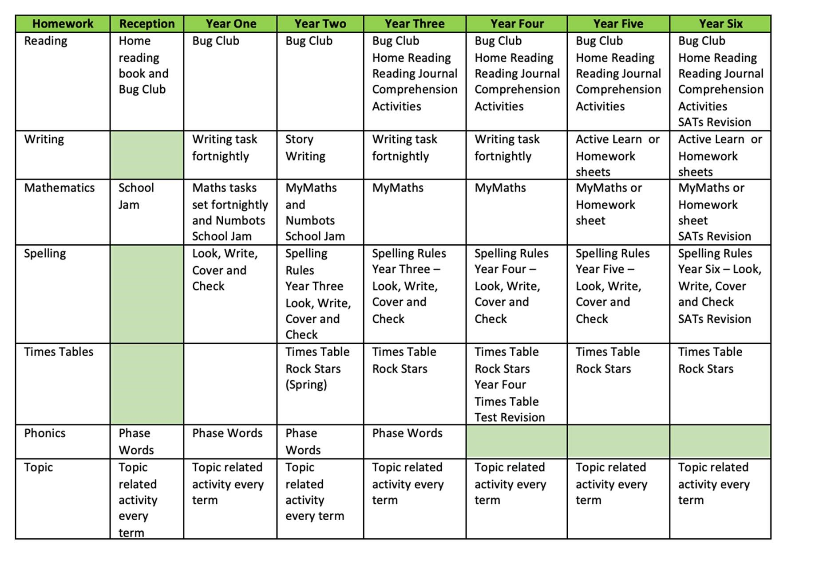 Please note:
- Children may be given additional or alternative homework to support their needs.
- Year One alternates Maths and English weekly.
- The wider curriculum topic may be set as a holiday project.
- Phonics phase words may be appropriate throughout the entire school. Class teachers will decide if they are appropriate for the pupils in their class.

12. Linked Policies

This policy should be read in conjunction with the Curriculum Policy, the Feedback Policy and the Behaviour Policy.

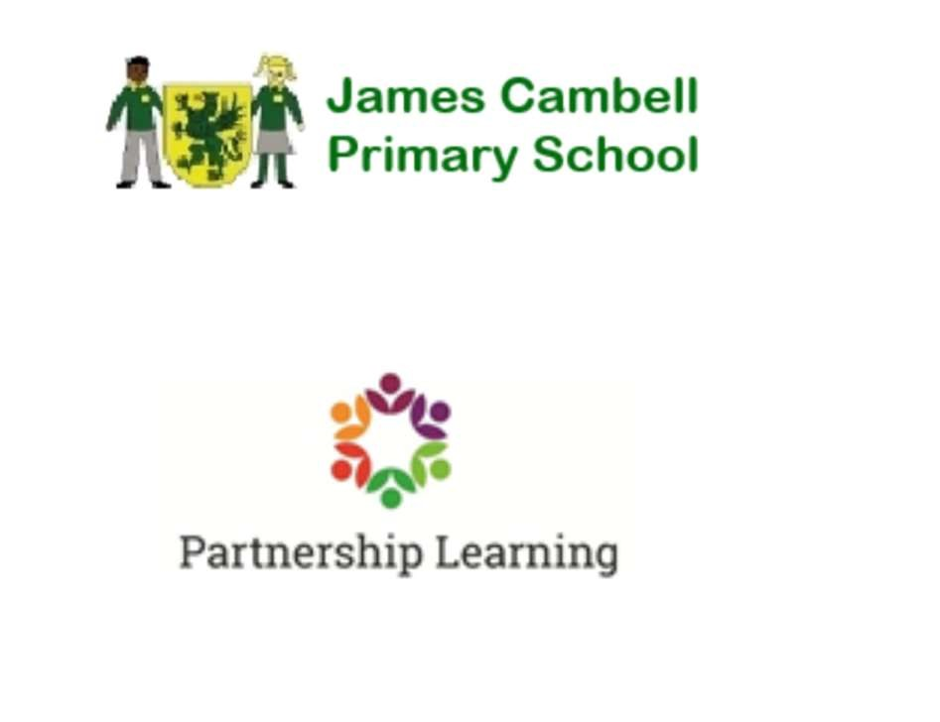

James Cambell Primary Teaching and Learning Policy
Appendices

APPENDIX 1: The Lesson Cycle - Principles of instruction

Barak Rosenshine’s ‘Principles of Instruction’ has become increasingly influential in educational research and practice since its publication a decade ago. Rosenshine (1930-2017) was formerly a professor of educational psychology in the College of Education at the University of Illinois. His research focused on cognitive science and observational studies about what effective teachers do in the classroom. His Principles are far reaching but concise and are best if looked at in conjunction with the work of other key researchers including:
- Graham Nuthall: The Hidden lives of Learners

- Daniel Willingham: Why Don’t Students Like School

- Sweller: Cognitive Load Theory

- Shimamira: A Whole Brain Learning Approach for Students and Teachers

- Dylan Wiliam: Embedded Formative Assessment

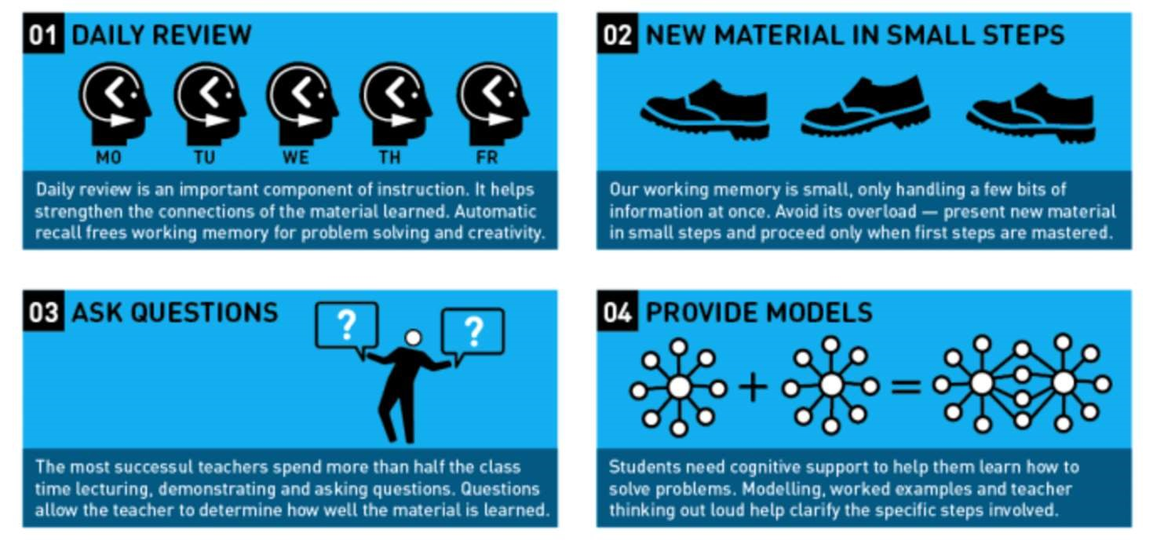
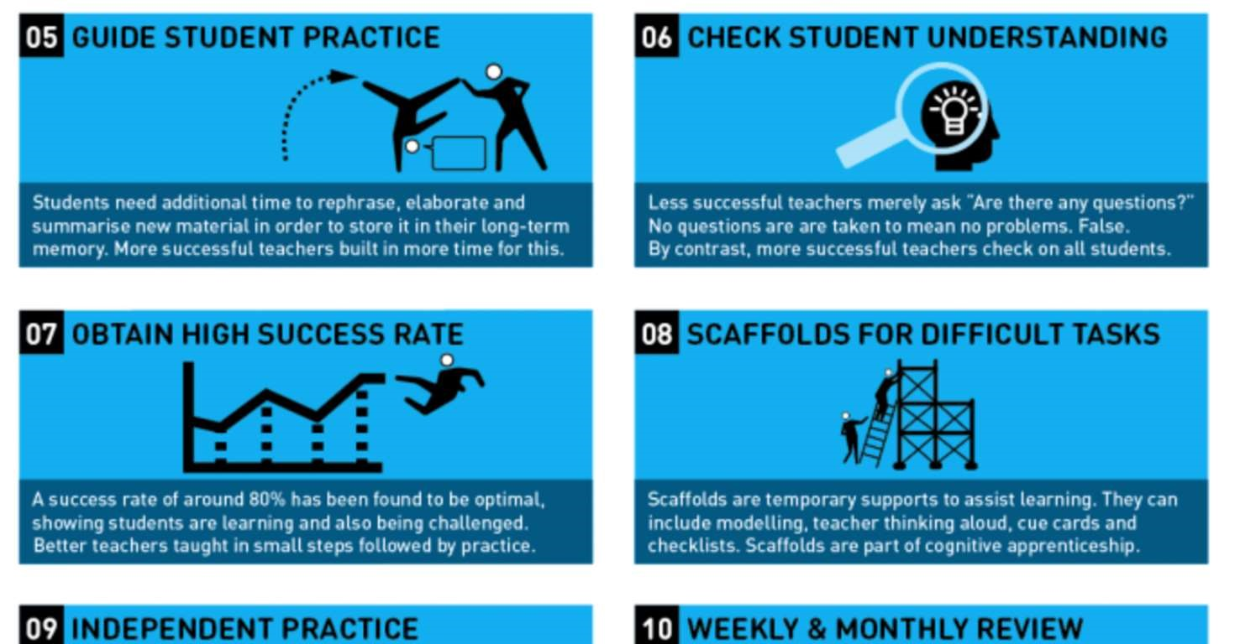
The magic of Rosenshine’s principles is that they are applicable to all teachers of all subjects and contexts. They focus on skills that teachers need to be successful in the classroom. From a pedagogical point of view, all of the teacher standards are addressed or at least can be related to the individual principles; Rosenshine encapsulates how to effectively teach in a very clever nutshell. All of this means that the approaches put forth are not subject-specific, so the theory and thinking behind each principle can be applied no matter what you teach. Like all good pedagogical theory, Rosenshine’s principles are underpinned by classroom practice. To be truly outstanding, you need to be able to reflect and adapt your practice. Rosenshine’s principles offer a framework to do that, with a sharp focus on improving, rather than the frequently wordy and vague Teacher Standards.

One of the best ways to engage with Rosenshine is to not think of the principles as a recipe; instead, think of them as more of a number of potential ingredients that can be combined depending on need.

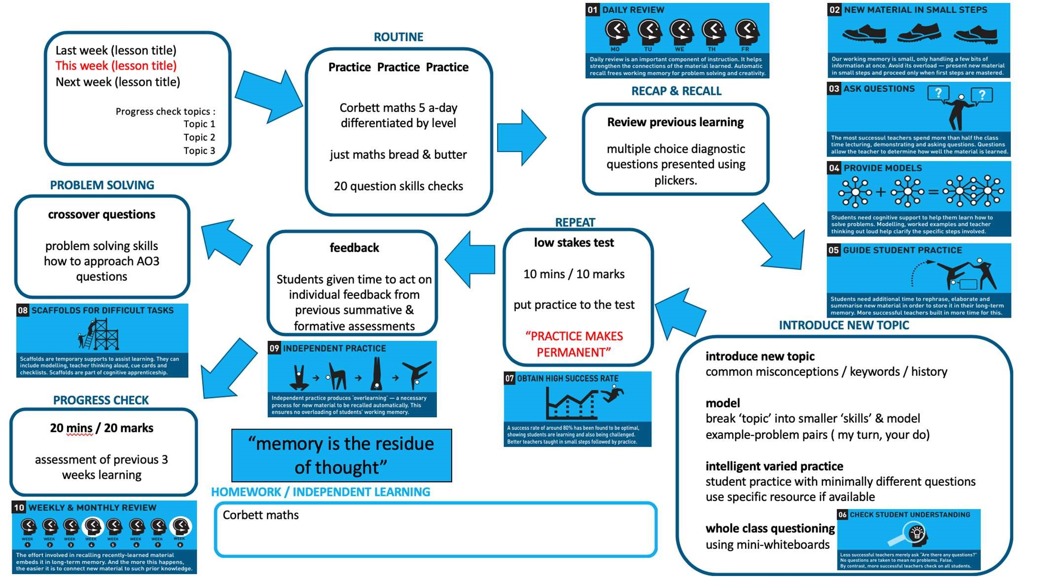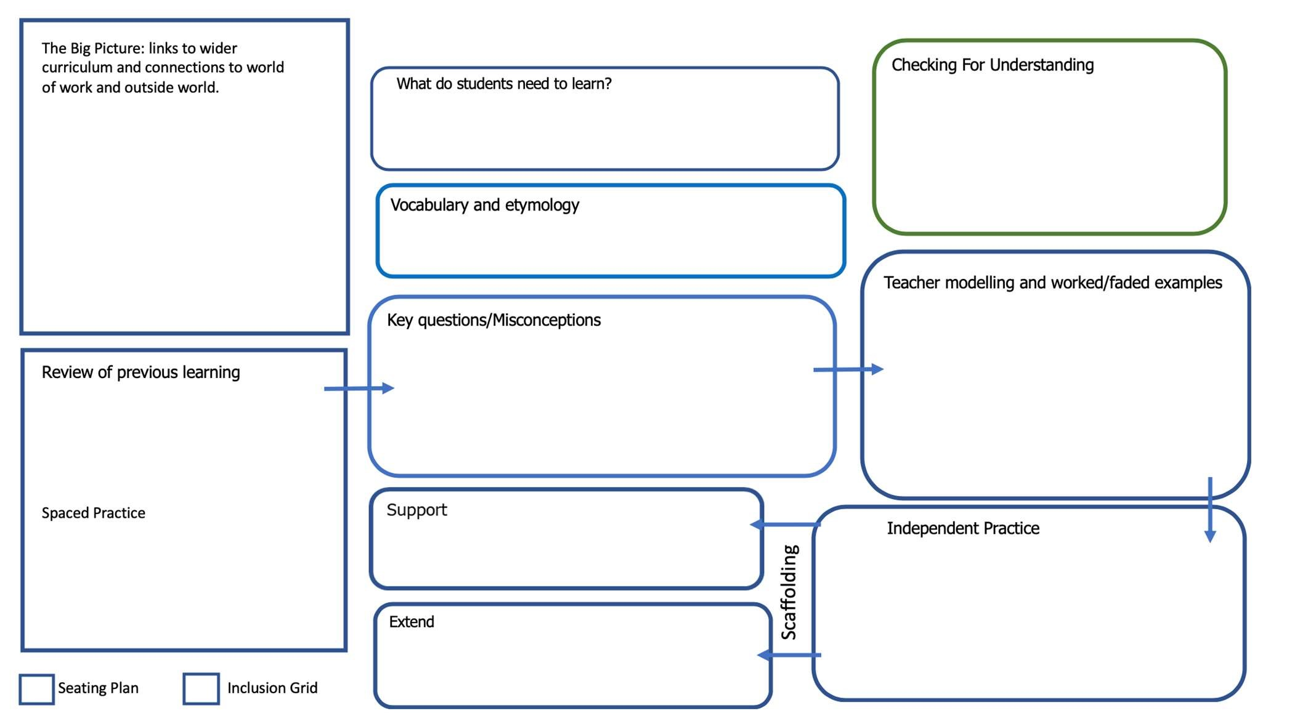

APPENDIX 2: Using the principles of instruction to plan. Example planning grids

APPENDIX 3: Rubrics

Rubrics are extremely useful for pupils: they let pupils know what is expected of them, and demystifies grades by

clearly stating, in age-appropriate vocabulary, the expectations for a lesson. Rubrics also help teachers authentically monitor pupil’s learning process. Rubrics are also important because they help clarify for pupils the qualities their work should have. For this reason, rubrics help teachers teach, help co-ordinate instruction and assessment, and

they help pupils learn. They make assessing pupils’ work efficient, consistent, objective and quick. They allow teachers to accommodate and differentiate effectively.

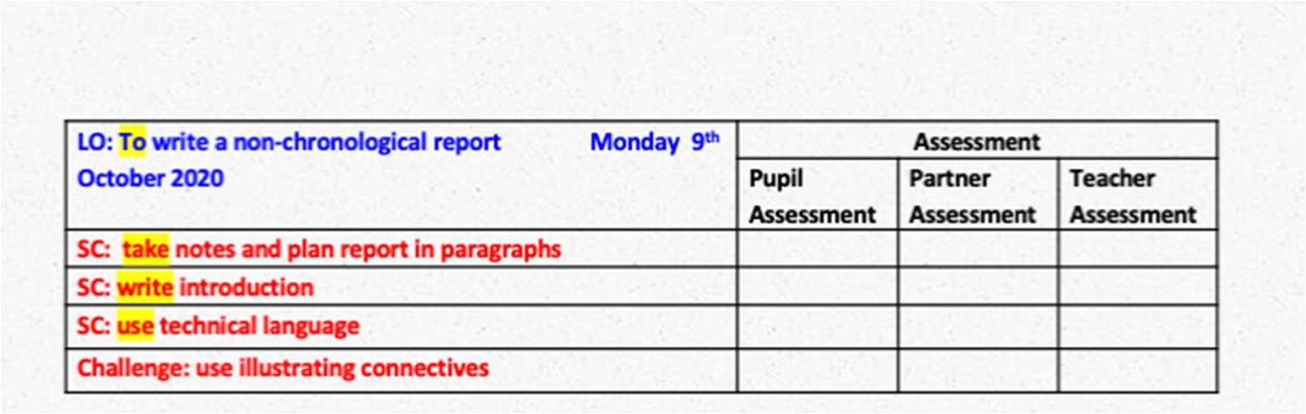
Date and learning objective are written at the top.

Success criteria begin with an imperative verb.
Children mark in green pen and teachers in red.

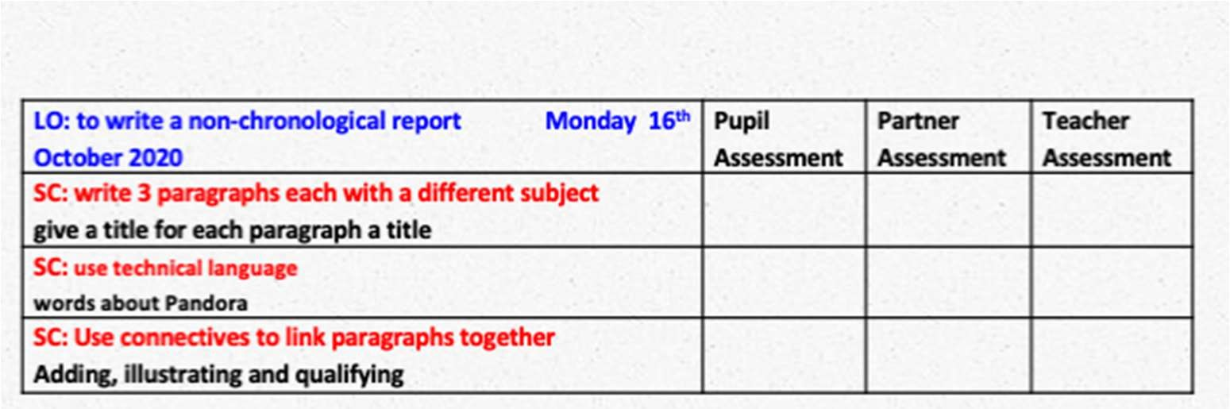
All lesson have a rubric and are stuck in at the beginning of each lesson.

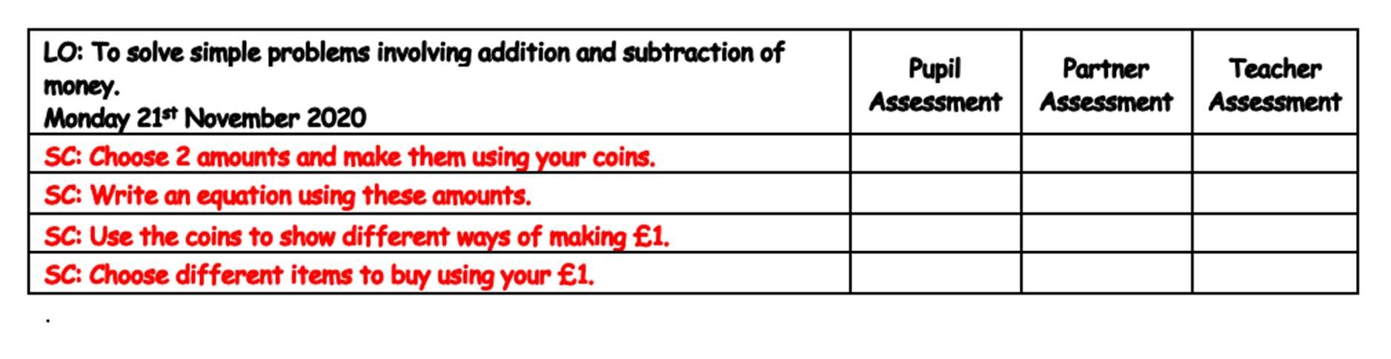
All rubrics to be ticked by the end of the day ready for the next lesson.

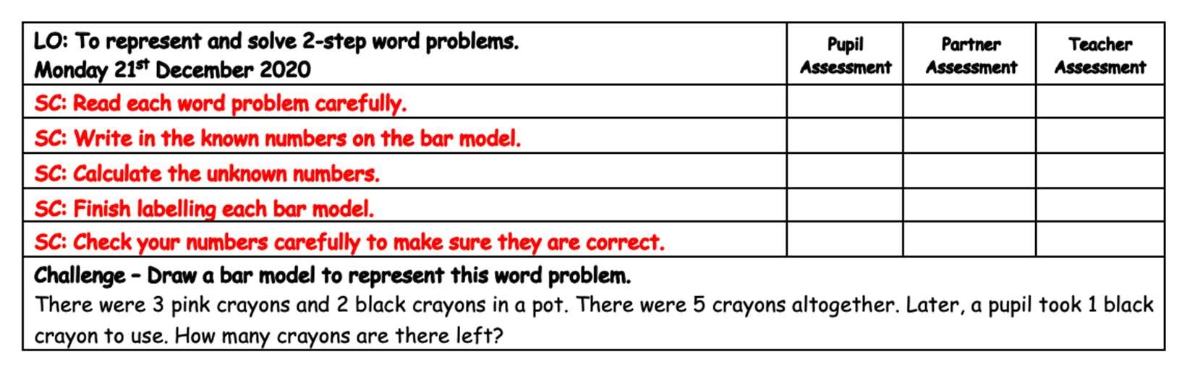
All rubrics are differentiated and could have a challenge.

APPENDIX 4: Working Walls

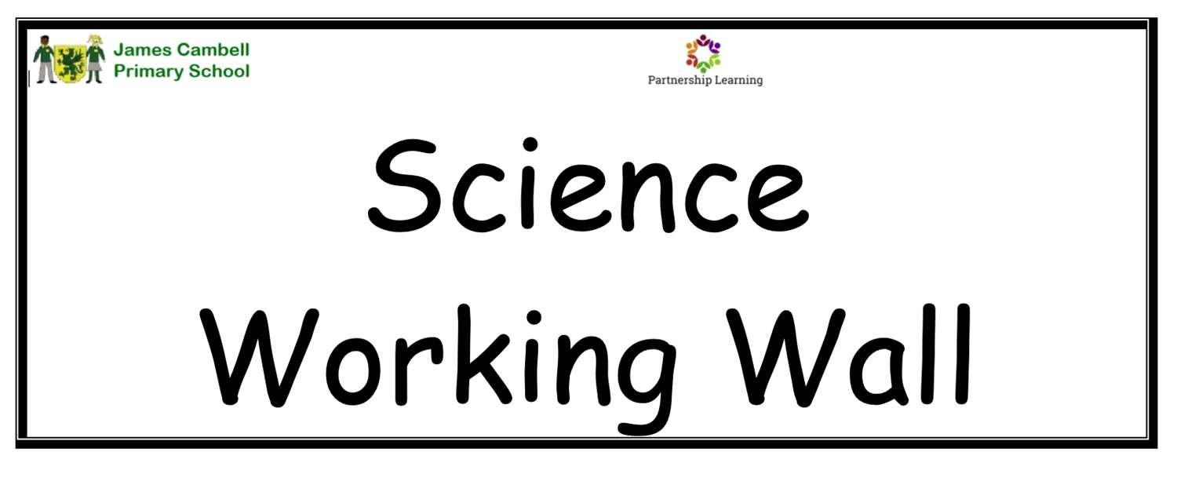

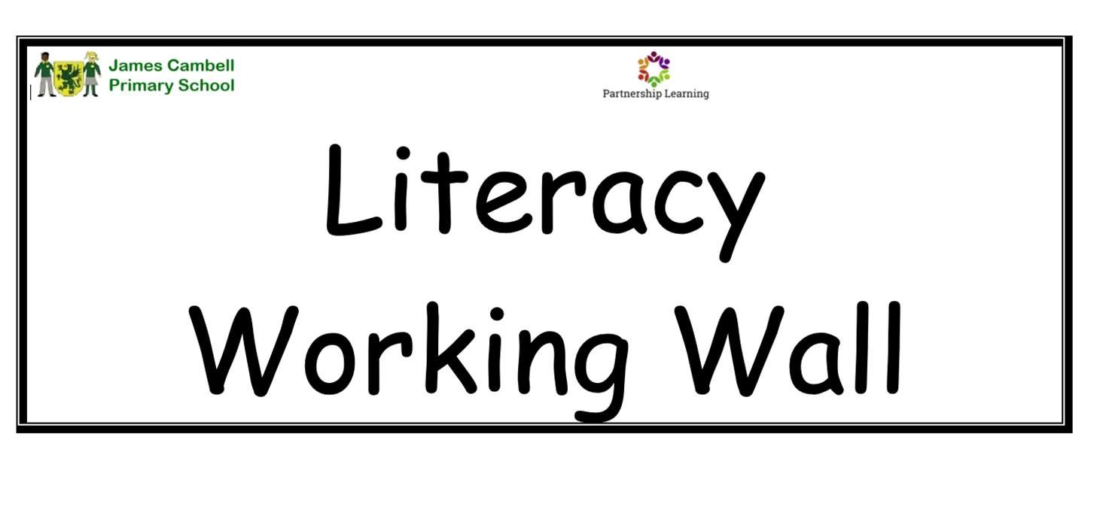

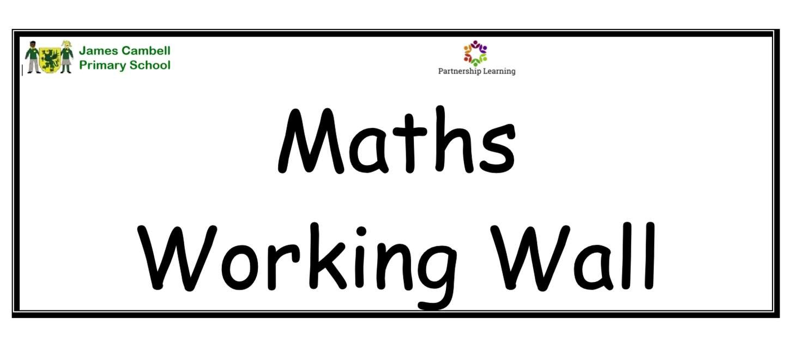

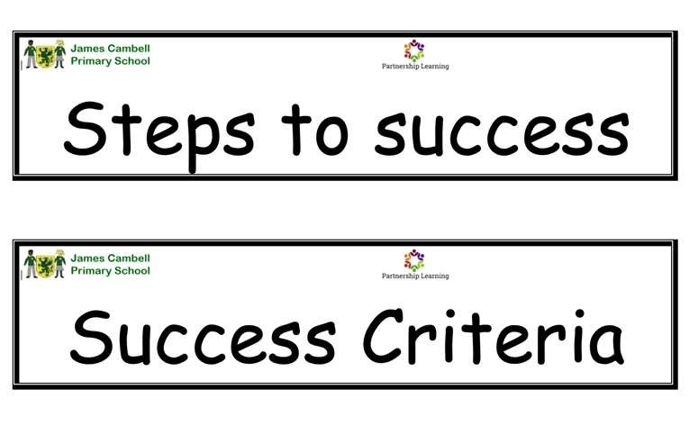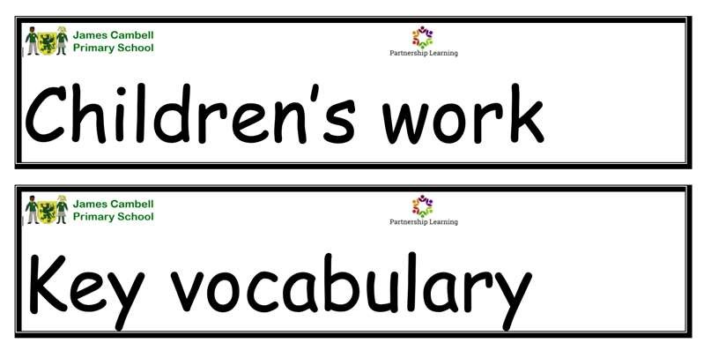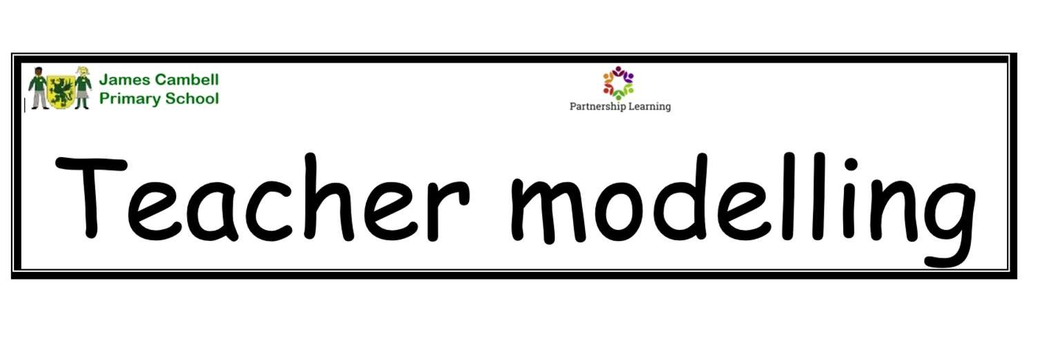

APPENDIX 4: Working Walls

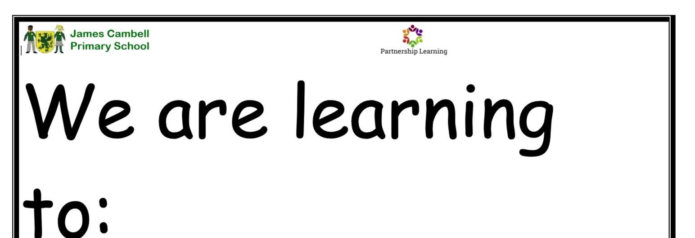

APPENDIX 5: Book corners

Most children like to sit down and get comfy so that they can free their mind and travel in their story book. A classroom boo k corner should create excitement for reading before the pupil has even selected a book. It’s important the books are easily accessible and easy to view.

One of the most important aspects you need to consider when designing a reading corner is the lighting. Staff need to spend time planning and maintaining the area, and books need to be tided and changed regularly. Favourite books should be available all the time but new ones and books to support topics should also be included.
Some helpful idea are:
- The area needs to be large enough to accommodate a group of children but small enough to be cosy.
- The area needs to be comfortable and welcoming atmosphere- use rugs, an old, comfy chair, cushions, plants, bean bag chairs, drape material from the ceiling to for a partition.
- Theme your book area. Gearing it towards the boys encourages them to use it more; however, having it topic based
means you are opening it up for all.

