Feedback Policy

Approved by: | Mr Joe Wilson | Date: 14/03/2023
Last reviewed on: | 14/03/2023
Next review due by: | Autumn 2023

James Cambell Primary School
Feedback Policy and Guidance 2021

This Policy and Guidance documents is written with a sole purpose of supporting and guiding all teachers of children at James Cambell Primary School, to ensure that the time spent on feedback is meaningful, manageable and motivational.

Effective feedback begins with clarity on what needs to be achieved – whether in the short-term (the lesson’s learning objective and success criteria) or long-term (for example, achieving that year’s National Curriculum objectives for a particular subject). Feedback is then an ongoing dialogue on how well a pupil is doing against those objectives and what the pupil needs to do next in order to align effort and activity with the desired outcome.

Feedback can take a variety of forms, verbal and written. The feedback can be about the learning activity itself, about the process of activity or about the pupil’s management of their learning or self-regulation.

The teachers’ standards state that teachers should ‘give pupils regular feedback, both orally and through accurate marking, and encourage pupils to respond to the feedback.’

Providing effective feedback is challenging; however, to achieve maximum impact, feedback should follow these principles:
- Feedback should be specific, accurate and clear.
- It should encourage and support further effort and resilience.
- It should provide specific guidance on how to improve and not just tell children when they are wrong.
- It should come from peers as well as adults.
- It should take a variety of forms (verbal and written) dependent on the needs and understanding of the learner – this policy therefore provides a variety of options for the provision of feedback.

It is important to note that the quantity of feedback should not be confused with its quality. Clear, specific, synchronous oral feedback will have a greater impact in most instances than receiving detailed formative marking comments some days later.

The critical purpose of feedback and marking is simple: Feedback should and can: SUPPORT, CONSOLIDATE, ACCELERATE, CHALLENGE and show that MISTAKES can be part of the learning process.

The cycle of feedback impacting on learning at James Cambell Primary is: ASSESS, PLAN, TEACH, REPEAT

The aim of feedback for pupils is to enable:
- Pupils to act on feedback to make progress overtime.
- Pupils to have a clear indication of how far they have come in their learning and the extent to which they have achieved learning objectives and/or targets and what they now need to do to improve.
- Develop independence and skills in self-regulation.
- Increase motivation.

Aim of feedback for teachers:
- Inform future planning and teaching.
- Show that we value pupils’ work, the effort and hard work they have done.
- Ensure high expectations.
- Ensure peer and self-assessment is part of the formative assessment strategies and this is used as part of the range of strategies for feedback.

Minimum Requirements that impacts on learning through feedback.

All work needs to be acknowledged by the class teacher- the Learning Objective and Success Criteria needs to be ‘pinked’ or ‘greened’ with the appropriate highlighter.

- There should be a minimum of one ‘deep mark’ from the teacher in English, maths and the wider curriculum per week (this can be done with the pupil in class or after the lesson).
- Teachers should exercise judgement in which pieces of work are most appropriate for deep marking. Teachers should also exercise judgement in deciding the most effective approach to marking other work (although the green and pink highlighter approach needs to be followed as a minimum for the learning objective and success criteria in all work).

In depth marking:

- Teacher to comment (in purple pen) on what the child has done well according to the Learning Objective and Success criteria.
- Next Steps: consolidate learning (e.g through addressing a misconception); provide a challenge or ask for a reflection on learning. The children will respond using their green pen.

All in-depth marking should deepen children’s understanding from that lesson, rather than asking/questioning children about learning which has not happened yet.

Can you write a sentence using a contraction as this was part of the learning objective?
In two sentences, can you explain how you were able to solve these number sentences?

Below is an example of the minimum requirement for feedback across the week in one subject:

Monday | Tuesday | Wednesday | Thursday | Friday
On the spot feedback | On the spot feedback | On the spot feedback | On the spot feedback | On the spot feedback
Verbal Feedback & work  acknowledged by the class teacher | Verbal Feedback & work  acknowledged by the class teacher | Star and Next Step/  Purple Pen- deep mark | Verbal Feedback & work  acknowledged by the class teacher | Verbal Feedback & work  acknowledged by the class teacher

Principles of Feedback

Feedback is valuable when it is received, understood and acted on. How pupils analyse, discuss and act on feedback is as important as the quality of the feedback itself. Through the interaction pupils have with feedback, they come to understand how to develop their learning.

We want our children to develop as independent learners, with an awareness of their own strengths as well as being skilled and able to tackle areas for development. Therefore, it is essential that feedback is:

- Timely-takes place with the pupil and is shared as immediately as possible - an emphasis on real time marking or on the spot marking
- Meaningful-it should target individual needs, be linked to specific assessment criteria, and be received by a pupil in time to benefit subsequent work.
- Feedback forms an informative and accessible dialogue with clear teacher and pupil
- Clear provision is made for opportunities to reflect and act upon improvement comments, thereby moving learning forwards
- Improvement is valued and clearly evidenced
- The children are made aware of learning objectives and of the success criteria that their work will be assessed against, in age-related vocabulary
- The learning needs of individual children are understood including those with SEND, and work is matched and marked appropriately

Types of Feedback

The Education Endowment Foundation’s report ‘A marked improvement?’ provides a useful, but not exhaustive, diagram of the types of feedback.

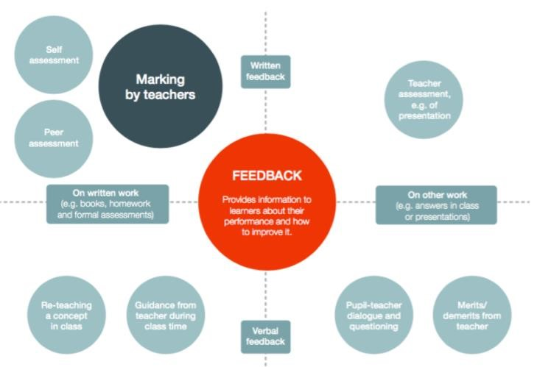
It is vital that teachers evaluate the work that children undertake in lessons, and use information obtained from this to allow them to adjust their teaching. Feedback occurs at one of three common stages in the learning process:
- Immediate feedback – at the point of teaching
- Summary feedback – at the end of a lesson/task
- Review feedback – away from the point of teaching (including written comments where appropriate)

The stages are deliberately numbered in order of priority, noting that feedback closest to the point of teaching and learning is likely to be most effective in driving further improvement and learning, especially for younger pupils. As a school, we place considerable emphasis on the provision of immediate feedback. Where feedback is based on review of work completed, the focus will often be on providing feedback for the teacher to further adapt teaching.

Type of Feedback | What this looks like | Evidence
Immediate | Includes teachers gathering feedback from teaching, including mini- white boards, book work, etc  Takes place in lessons with individuals or small groups.  Often given verbally to pupils for immediate action.  May involve the use of teaching assistant to provide support or further challenge.  May-redirect the focus of teaching or the task.  May include highlighting/annotations. | - Lesson observations/learning walks  - Some use of annotations or highlighting.
Summary | Takes place at the end of a lesson or activity.  Often involves whole groups or classes.  Provides an opportunity for evaluation or learning in the lesson.  May take form of self-or peer-assessment against an agreed set of criteria.  In some cases, may guide a teacher’s further use of review feedback, focusing on areas of need. | - Lesson observations/learning walks.  - Timetabled pre-and post- teaching based on assessment.  - Some evidence of self-and peer- assessment.  - May be reflected in selected focus review feedback (marking).
Review | Takes place away from the point of teaching.  May involve written comments/annotations for pupils to read and respond to.  Provides teachers with opportunities for assessment of understanding.  Leads to adaptation of future lessons through planning, grouping or adaptation of tasks.  May lead to targets being set for pupils’ future attention, or immediate action. | - Acknowledgement of work completed.  - Written comments and appropriate responses/action.  - Adaptations to teaching sequences tasks when compared to planning.  - Use of annotations to indicate future groupings

There can be no ‘one size fits all’ approach to the best type of feedback. The overriding principle is that a teacher should use their professional judgement in determining which type of feedback is most useful dependent on the needs of the children. This will comprise a range of feedback options as summarised in the table below.

Feedback options | Description | Comments on effectiveness
Longer term targets | These are discussed and agreed with the children so that children are clear where they are going. | Targets need to be reviewed regularly to be effective – and to be achievable (i.e. not too long-term).
Learning objectives and success criteria | Learning objectives describes what the child should be learning in a lesson; the success criteria are a checklist to assess whether the learning objective has been met. | By informing a child where they are going within a lesson – these are a prerequisite for effective feedback.  To be effective, learning objectives and success criteria need to be clear and precise; in child-friendly language (and explained where necessary); shared with the children; referred to in the plenary. When appropriate, children should contribute to the success criteria.
Verbal feedback to individuals  (pupil/teacher dialogue) | This can be based on different categories:  - feed up (where is my learning going?)  - Feedback (how is my learning going?)  - Feed forward (where to next?)  The feedback can be about the learning activity itself, about the process of activity or about the pupil’s management of their learning (self-regulation) | Research indicates that this is likely to have a very high impact, but the feedback needs to be specific, clear and accurate. Non-specific personal feedback about the pupil as a person (eg ‘good girl’ or ‘great effort’) is unlikely to have an impact.
Teaching or reteaching a concept | Teacher-directed learning | Feedback is not useful if the gap in understanding is too large – in these cases, it is better to re-teach the concept or to break concept into smaller parts.
Mini plenary | Learning can be accelerated by the use of whole-class mini-plenaries (for example to address misconceptions), leaving time for a short lesson plenary at the end. Open dialogue with children during a lesson is a powerful lever for progress – how well are you doing, how could you improve your learning? | High impact can be achieved following a review of how the class is progressing and providing a clear direction on the next steps.
Lesson plenary | This needs to focus on summarising learning and the next steps. | Telling children what they need to do to improve, without the opportunity to put this input into practice is not likely to achieve much.
Open questioning | Use of open questions can help develop higher order patterns of thinking. | Teachers need to give thinking time having asked questions (and time for partner/group talk), and time should be given for children to respond in order for children to elaborate and explain their answers.  To be most effective, the classroom climate needs to be conducive to dialogue, with mistakes being welcomed and teachers seen to be learning from children as well as vice versa.
Written marking | Written comments in the child’s book from the teacher. | Needs to be balanced against the ‘6 feedback strategies. Marking is unlikely to be effective unless completed with the child during the lesson or dedicated time (DIRT page 10) is given to the pupil to consider and address comments.
Peer assessment, peer tutoring  and/or peer marking | Peer assessment/marking - A peer assesses a piece of work using the success criteria.  Peer tutoring – one child providing support to another in progressing their learning. | At its most effective, peer assessment can be powerful in promoting meta-cognition, collaborative learning and greater autonomy in learning. Research suggests that pupils will often accept the comments of peers more readily than those of the teacher. Peer tutoring has also been shown to be highly effective in raising achievement and that benefits flow both ways, sometimes benefiting the ‘expert’ in the relationship even more than the ‘novice’.  However, all forms of peer assessment require modelling and practice to be accurate and effective. It is therefore unlikely to have the same impact in younger year groups.
Self-assessment | A child assesses his/her own work using the success criteria. | As with peer assessment, self-assessment can help develop meta-cognition and greater autonomy in learning.  To be effective, children need to have sufficient understanding and awareness of the learning objective and success criteria – this requires modelling and practice.

Feedback Guidelines

- All written comments, corrections or check marks should be in purple pen.
- If a calculation is incorrect, then a green mark will be left beside the calculation which then needs to be revisited by the child and corrected.
- When children are editing a piece of work – this needs to be done in green pen.
- Feedback needs to happen during or at the end of a piece of work, so that children can read, comment and respond – time needs to be planned into subsequent lessons to ensure children have time to write a response.
- Teachers should plan for DIRT (Dedicated Improvement and Reflection Time- page 10) when appropriate, ensuring that time is given to allow pupils to improve upon their work and make gains to their learning.
- If a supply teacher or HLTA is covering a class – they must mark in red and write SUPPLY in the margin along each piece of work.
- Codes need to be used for moderation and monitoring purposes. These codes need to be written in the margin alongside the work if needed:

S – Supported in a small group or 1 to 1.
G – Guided work with teacher.
Supply- Work produced with a supply teacher.
VF – Verbal feedback given or verbal feedback stamp.
Self-Assessment (with green pen) – if a child has used self-assessments as a marking strategy on their work.
Peer Assessment and sign their name (with green pen)– if a child has used peer assessment as a marking strategy on another child’s work (marked by…).

Pink and Green highlighters are used to show children their successes and work needed for improvement

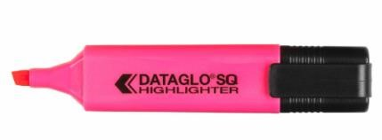
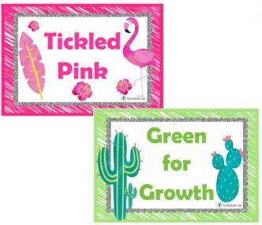
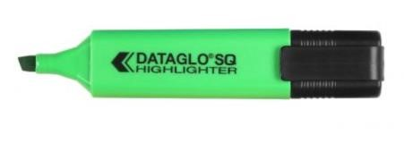
Pink highlighter – tickled pink by success.
Green highlighter – green for growth-work
which needs further work or response by the
children in green pen.

Equipment needed for this Feedback Policy:

A purple pen- teachers and children’s purple pen responses

Green editing pens for all children
Blue pens for all children with a pen license- pencil for all others
A Gold Star stamp
A Next step stamp
A Verbal Feedback step stamp

Feedback Guidance in Early Years

All feedback is verbal in Nursery and Reception.
A star can be used to celebrate the children’s successes.
Feedback and assessments are recorded in the children’s individual Learning Journeys.

Depending on the stage and development of some children in Reception in the Summer Term, children will be encouraged to edit and improve their writing or mathematical work in preparation for Year 1 – this is at the teachers’ discretion.

Marking and Feedback in practice at KS1 and KS2 at James Cambell

The impact of your feedback can be significantly beneficial to the pupils it is for. We need to focus on giving smarter feedback in order to have the greatest impact on pupils.

Below is an example of how you could give feedback across the week in one subject.

Monday | Tuesday | Wednesday | Thursday | Friday
On the spot feedback | On the spot feedback | On the spot feedback | On the spot feedback | On the spot feedback
Verbal Feedback | Self-Assessment | Peer- Assessment | Green Box | Star and Next Step/ Purple Pen

OUR 6 STRATEGIES TO IMPACT ON LEARNING THROUGH FEEDBACK-based on the needs of the children
1. On the Spot Verbal Feedback | 2. Star and Next Step Stamp | 3. The Green Box
Pink and green highlighters to be used in learning time – on the stop, real time feedback  − Pink is for tickled pink – a celebration of success against LO and SC  − Green is for growth and Improvement needed  Evidence of green pen response to verbal feedback can be given during learning  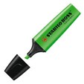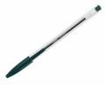 | Star stamp can celebrate successes  Next Step Stamps can be used to focus on children’ next steps for improvement or a purple pen task children need to do  These stamps are used for in-depth marking ensuring children know what to do to improve in their work | The strategy can be used in various ways. It is a zonal and focused strategy for both teachers and pupil.  - A teacher can draw a Green Box, using a green highlighter around a section of a child’s work and give in-depth feedback against the LO or SC rather than the whole piece – a really in-depth piece of marking for the child to focus on and respond to. The Star and Next Step stamps can be used to structure the Green Box marking for the child to understand what went well and what the child needs to do next to improve.  - A teacher can draw a Green Box, using a green highlighter around a section of a child’s work and ask for the child to edit this piece of work only, rather than the whole piece.  Teachers can use this feedback strategy to smartly address the Lo and SC in an effective and focused way – this is called ‘zonal’ marking.
4. Self-Assessment | 5. Peer Assessment | 6. A Purple Pen Question
Teachers can use self-assessment across the week in order for children assess their learning/work in any subject.  Making judgments about the progress of one’s own learning is integral to the learning process – this is self-assessment.  The self-assessment, referring to relevant success criteria and learning objective, need to be taught explicitly – this takes time and constant training and developing for impact.  Opportunities and time for self-assessment needs to be planned into lessons or can be done as part of the learning process.  If a child self-assesses they need to write Self-Assessment under the piece of work they have self-assessed | Teachers can use peer assessment across the week in order for children to mark and assess each other’s work in any subject.  Peer assessment involves students providing feedback and next steps to other students on the quality of their work.  The skills of peer -assessment, refer to relevant success criteria and learning objective, need to be taught explicitly – this takes time and constant training and developing for impact.  If children peer assesses, they need to write Peer Assessment and sign their name in their peer’s book | A Purple Pen Question is used to challenge or consolidate learning.  This can be done during the learning or after the learning for the children to respond to at the beginning of the next lesson – this can be used as an assessment opportunity.  Purple pen Questions are linked to the LO. They should be used to prompt higher –level thinking or application of skills. Purple Pen Questions may require children to apply the skill in a different context, explain their understanding, prove an answer or solve a problem; consolidate what they have been learning for AfL purposes. Blooms Taxonomy questions can be asked in order to structure the children written response.  For example:  − Explain how you reached the answer in number 3  − What do you understand about how the heart works  – show what you know using a diagram  − Predict what might happen at the end of the story  − This is a scalene triangle – TRUE or FALSE? Explain your reasoning

OUR 6 STRATEGIES TO IMPACT ON LEARNING THROUGH FEEDBACK- Examples
1.On the spot Feedback- continual

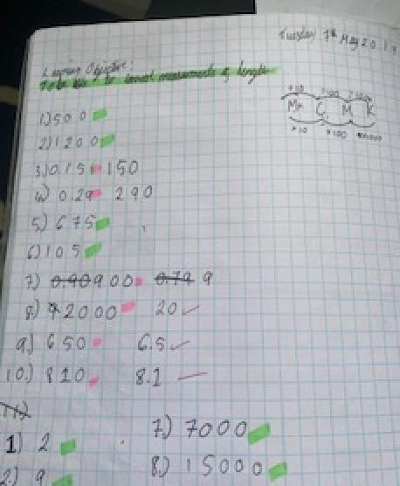  On the sport feedback can also include mini plenaries, re-teaching a concept and open-ended questioning. | Pink and green highlighters to be used during learning time – on the stop, real time feedback.  Children respond to your feedback with their green pen.  This is an opportunity to quickly address misconceptions and move the learning on.  Teacher uses red pen, green and pink highlighters and the children use a black pen or pencil and when addressing mistakes, use their green pen.  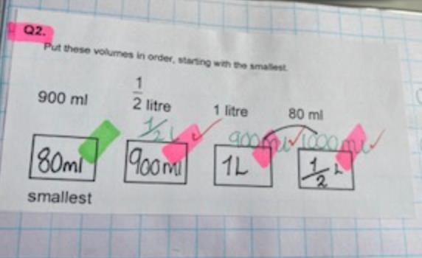
2.Star and Next Step Marking
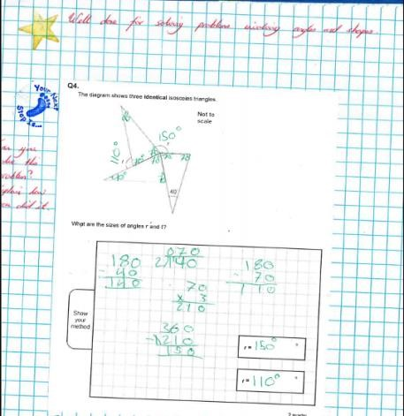  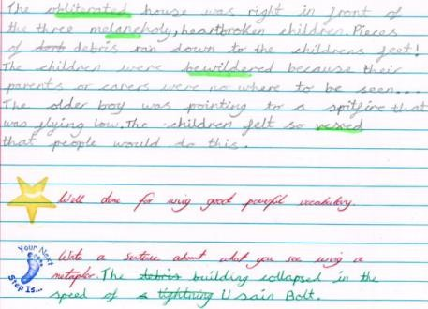 | These stamps are used for in-depth marking ensuring children know what to do to improve in their work.  They link very carefully to the learning objective and success criteria.  What have the children done well according to the learning objective  and success criteria- be very explicit.  What do the children have to improve according to the learning objective and success criteria- be very explicit.  Teacher to write comments in red pen and children to respond in green pen.

3.The Green Box- zonal marking
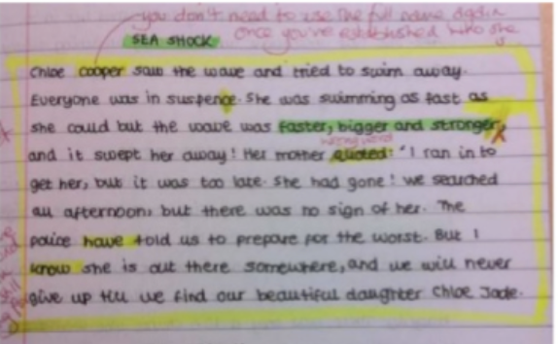  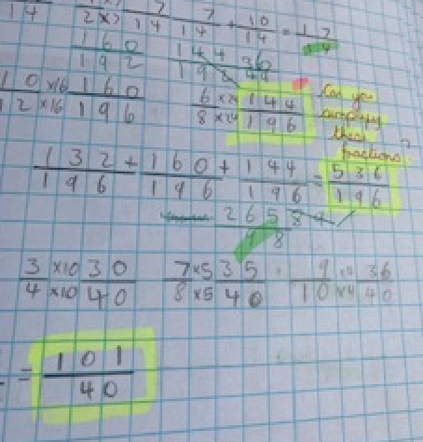 | Option 1  Draw a Green Box, using a green highlighter around a section of a child’s work and give in-depth feedback against the Learning Objective or Success Criteria rather than the whole piece.  Option 2  Draw a Green Box, using a green highlighter around a section of a child’s work and ask for the child to edit this piece of work only, rather than the whole piece.  Remember:  Choose one area of a child’s work to mark. Just one section. Mark it well and in detail and offer sophisticated feedback and no matter what, ensure that the feedback is specific and diagnostic.
4.Self-Assessment
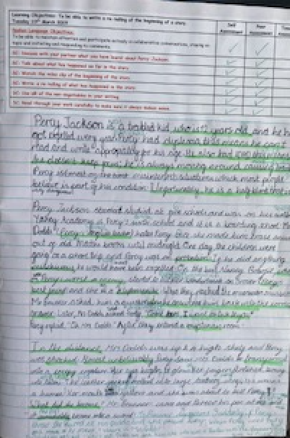 | Self-assessment can provide insight into pupils'  true comprehension and can help to identify gaps in pupils' knowledge. This approach promotes a shift towards pupil-centered learning in which students define their own goals and the steps required to meet them.  The self-assessment, referring to relevant success criteria and learning objective, need to be taught explicitly – this takes time and constant training and developing for impact.  Remember:  Opportunities and time for self-assessment needs to be planned into lessons or can be done as part of the learning process. Once children have assessed their work, they then need time to improve it with their green pen-DIRT.  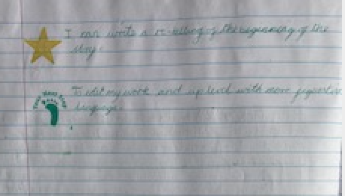
- Peer Assessment
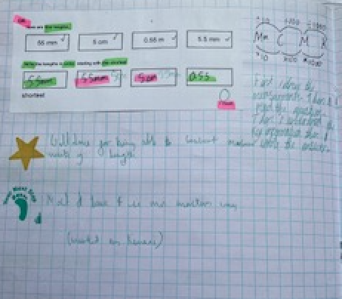 | Peer assessment involves pupils providing feedback and next steps to other pupils on the quality of their work in green pen, referring to the learning objective/success criteria. It is also important for the child to sign their name in their partners book- (marked by…)  Remember:  Opportunities and time for peer-assessment needs to be planned into lessons or can be done as part of the learning process. Once children have assessed their work, they then need time to improve it with their green pen-DIRT.  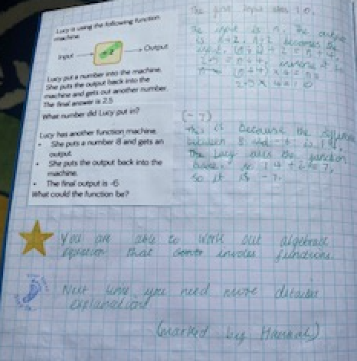

- Purple Pen Question

A Purple Pen Question is used to challenge (more able) and is linked to the learning objective. Children respond using their purple pens.

This can be done during the learning or after the learning for the children to respond to at the beginning of the next lesson (DIRT Time) – this can be used as an assessment opportunity.

What is DIRT?
Dedicated Improvement and Reflection Time

DIRT stands for Dedicated Improvement and Reflection Time and these sessions give children a daily opportunity to:
Reflect on their learning and progress
Make improvements through reviewing and editing processes
Tackle further work to either consolidate their understanding or extend them towards mastery of a given skill.
DIRT time gives pupils a specific structure as to when they need to stop, think for themselves and make their own decisions as to where they want to go next with their own learning. This process is quite an easy process to employ in a classroom environment, and it is all based around the feedback. Dirt time is planned time either at the start, during or can be as the main focus of a lesson, DIRT sessions can take as long as teachers feel necessary. As well as specific slots on the timetable, they can form the starter of a lesson or for longer pieces of work (such as editing and redrafting stories) may take a whole lesson. It can be 2 minutes or 30 minutes depending on how you plan to allow them to act on your feedback This dedicated time allows children to get the most out of chosen learning activities; embedding and extending knowledge skills and understanding.

A Green Box can be drawn around a section of writing the children can focus on to improve and redraft Time is given for children to read their targets. Using a green pen; children go back through their work and make the improvements.

Examples of DIRT activities:
Correct mistakes and spelling
Using a thesaurus or dictionary to develop vocabulary choices
Introducing more ambitious punctuation
Changing sentences structures
Correcting to consistent use of tense
Rewriting part or whole of their writing
Publishing their improved writing – focus on handwriting

DIRT CHECKLIST to develop independence (this can be adapted for age and stage)

