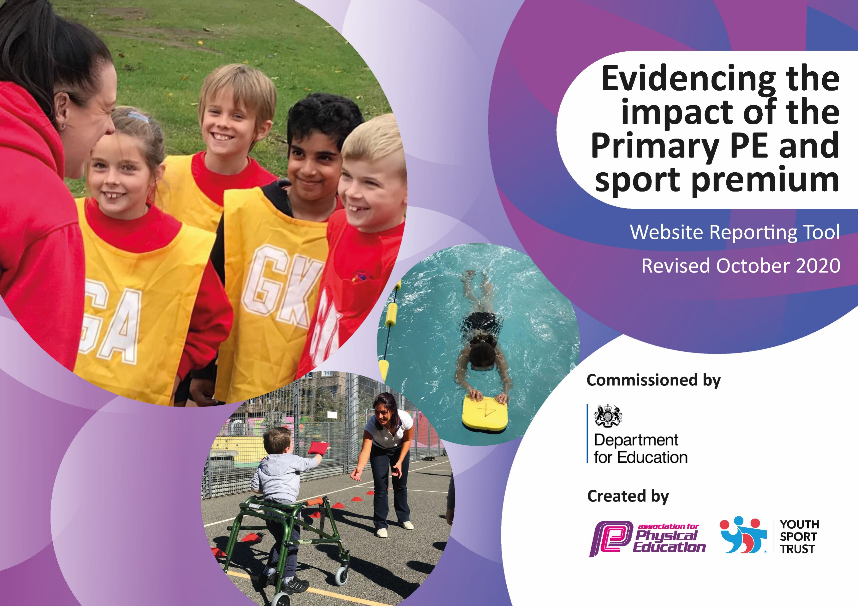
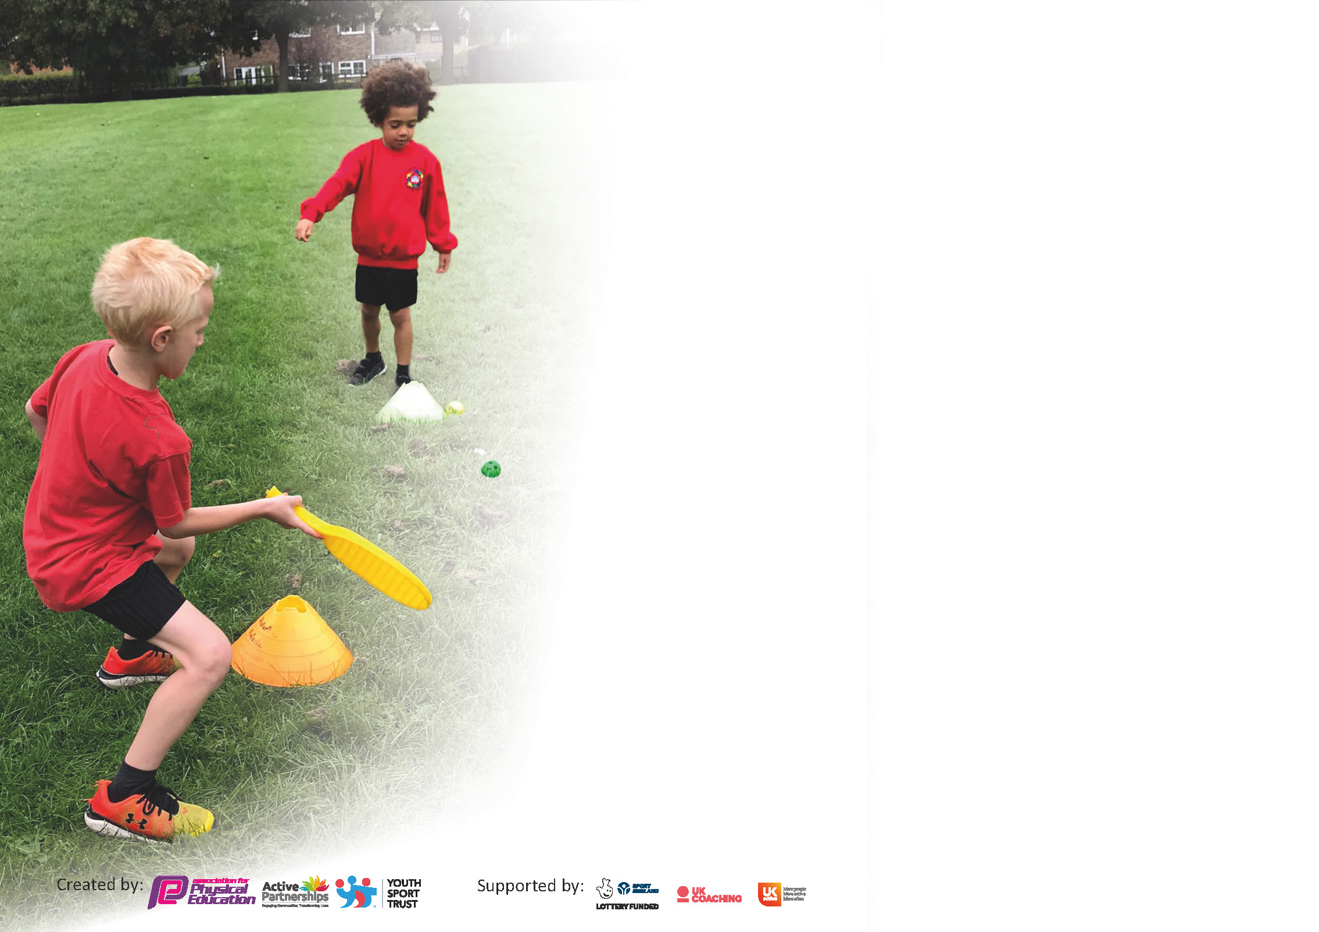

It is important that your grant is used effectively and based on school need. The Education Inspection Framework (Ofsted 2019 p64) makes clear there will be a focus on ‘whether leaders and those responsible for governors all understand their respective roles and perform these in a way that enhances the effectiveness of the school’.

Under the Quality of Education criteria (p41) inspectors consider the extent to which schools can articulate their curriculum (INTENT), construct their curriculum (IMPLEMENTATION) and demonstrate the outcomes which result (IMPACT).

To assist schools with common transferable language this template has been developed to utilise the same three headings which should make your plans easily transferable between working documents.

Schools must use the funding to make additional and sustainable improvements to the quality of Physical Education, School Sport and Physical Activity (PESSPA) they offer. This means that you should use
the Primary PE and sport premium to:

- Develop or add to the PESSPA activities that your school already offer
- Build capacity and capability within the school to ensure that improvements made now will benefit pupils joining the school in future years

Please visit gov.uk for the revised DfE guidance including the 5 key indicators across which schools should demonstrate an improvement. This document will help you to review your
provision and to report your spend. DfE encourages schools to use this template as an effective way of meeting the reporting requirements of the Primary PE and sport premium.

We recommend you start by reflecting on the impact of current provision and reviewing the previous spend.

Schools are required to publish details of how they spend this funding as well as on the impact it has on pupils’ PE and sport participation and attainment by the end of the summer term or by 31st July 2021 at the latest.

** In the case of any under-spend from 2019/20 which has been carried over this must be used and published by 31st March 2021.

We recommend regularly updating the table and publishing it on your website throughout the year. This evidences your ongoing self-evaluation of how you are using the funding to secure maximum, sustainable impact. Final copy must
be posted on your website by the end of the academic year and no later than the 31st July 2021. To see an example of how to complete the table please click HERE.
Created by: Supported by:

Please note: Although there has been considerable disruption in 2020 it is important that you publish details on your website of how you spend the funding - this is a legal requirement.
Support for review and reflection - considering the 5 key indicators from DfE, what development needs are a priority for your setting and your pupils now and why? Use the space below to reflect on previous spend and key achievements and areas for development.

N.B. In this section you should refer to any adjustments you might have made due to Covid-19 and how these will influence further improvement.
Key achievements to date until July 2022: | Areas for further improvement and baseline evidence of need:
- Silver Award for School Games  - SEN group swimming consistently in KS2 - 1 session per week  - Increased participation in swimming for CPC children  - Purchase of more resources for encouraging greater activity at lunchtime and playtime.  - Increased confidence of all staff in teaching PE and sport – Particularly Cricket through whole school INSET training.  - New Scheme of work implemented across whole school.  - Assessment in PE highlights good attainment by pupils.  - SEND Children compete in borough competitions  - Inter-class competition is extremely successful, driving participation and improving behaviour  - Bikability success in KS2  - Partnership with Essex Cricket to support staff in delivering lessons and provide an after school club.  - Lunchtime and afterschool provision has improved significantly – being made available for all year groups  - Fundraising event held in school with professional GB athlete – inspiring pupils  - Dance/Reading workshop for KS1 a great success  - OPAL has been introduced and implemented well – huge improvements to playgrounds  - PE enrichment afternoons provided pupils with opportunity to try some more niche sports – Fencing & Archery | - Purchase more resources for encouraging greater activity at lunchtime and playtime (create circuits, orienteering points and trails)  - Improve behaviour within PE lessons – engage pupils further  - Drive vocabulary within PE and opportunities for cross curricular links  - Increased confidence of all staff in teaching gymnastics.  - Re-evaluate the range of clubs offered to promote participation in competitive sports.  - Essex cricket to support development of Cricket in school.  - Barking Rugby club to support development and implementation of Rugby in school.

Did you carry forward an underspend from 2019-20 academic year into the current academic year? NO

If YES you must complete the following section
If NO, the following section is not applicable to you

If any funding from the academic year 2020/21 has been carried over you MUST complete the following section. Any carried over funding MUST be spent by 31 March 2022.
Academic Year: September 2021 to March 2022 | Total fund carried over: £ | Date Updated:
What Key indicator(s) are you going to focus on? |  |  |  | Total Carry Over Funding:
 |  |  |  | £
Intent | Implementation |  | Impact
Your school focus should be clear how you want to impact on your pupils. | Make sure your actions to achieve are linked to your intentions: | Carry over funding allocated: | Evidence of impact: How can you measure the impact on your pupils; you may have focussed on the difference that PE, SS & PA have made to pupils re-engagement with school. What has changed?: | Sustainability and suggested next steps and how does this link with the key indicators on which you are focussing this academic year?:

Meeting national curriculum requirements for swimming and water safety.

N.B Complete this section to your best ability. For example, you might have practised safe self-rescue techniques on dry land.
What percentage of your current Year 6 cohort swim competently, confidently and proficiently over a distance of at least 25 metres?  N.B. Even though your pupils may swim in another year please report on their attainment on leaving primary school at the end of the summer term 2021. | 56%
What percentage of your current Year 6 cohort use a range of strokes effectively [for example, front crawl, backstroke and breaststroke]? | 33%
What percentage of your current Year 6 cohort perform safe self-rescue in different water-based situations? | 52%
Schools can choose to use the Primary PE and sport premium to provide additional provision for swimming but this must be for activity over and above the national curriculum requirements. Have you used it in this way? | Yes/No

Action Plan and Budget Tracking
Capture your intended annual spend against the 5 key indicators. Clarify the success criteria and evidence of impact that you intend to measure to evaluate for pupils today and for the future.

Academic Year: 2021/22 | Total fund allocated: £20,980 | Date Updated:
Key indicator 1: The engagement of all pupils in regular physical activity – Chief Medical Officers guidelines recommend that primary school pupils undertake at least 30 minutes of physical activity a day in school |  |  |  | Percentage of total allocation:
 |  |  |  | %
Intent | Implementation |  | Impact
Your school focus should be clear what you want the pupils to know and be able to do and about  what they need to learn and to  consolidate through practice: | Make sure your actions to achieve are linked to your intentions: | Funding allocated: | Evidence of impact: what do pupils now know and what can they now do? What has changed?: | Sustainability and suggested next steps:
Increase sports participation at lunchtime- particularly for those less active across the school. Stations and trails to be created in both playgrounds to develop fitness and activity of children. Playground equipment to be replenished to ensure children have resources to complete playground activities.  Extra-curricular clubs to be available for every year group, including CPC – in a range of different sports. | Equipment and markings to be added to the playground. MDAs, teachers and support staff to be trained in using areas.  Sports coach to run lunchtime and afterschool clubs across KS1 & KS2 - targeting the least active, least confident and those that would benefit from social interaction. | £5,200  £7,200 | Trails and stations will increase children’s activity during playtime. Children’s fitness and mental stamina to improve. Classes with long afternoons to use the break to help with children’s concentration.  Increase the children’s physical activity, as well as confidence, self-esteem and communication skills. | Lines in place and working well  Children are engaging at play and lunch times  Has worked well to improve behaviour  Improved PE provision  More range of activities available for children
Key indicator 2: The profile of PESSPA being raised across the school as a tool for whole school improvement |  |  |  | Percentage of total allocation:
 |  |  |  | %
Intent | Implementation |  | Impact
Your school focus should be clear what you want the pupils to know and be able to do and about  what they need to learn and to  consolidate through practice: | Make sure your actions to achieve are linked to your intentions: | Funding allocated: | Evidence of impact: what do pupils now know and what can they now do? What has changed?: | Sustainability and suggested next steps:
Staff, children, parents and governors have a keen interest in the participation of children in sporting events and encouraging participation in a wide range of sporting activities.  Intra-sports competition in place for all year groups. Children and staff will be engaged with the learning of the sport, in preparation for competition.  Improve the teaching of gymnastics across KS1 & KS2  Improve the outdoor experience in Reception – learning through play. To add resources and storage options for better organisation of the areas. | Sporting events are shared in the staffroom, meetings, school website and included on the weekly diary to ensure that all staff support the teams of the school. Successes and participation is shared with children in assemblies with trophies, medals and certificates being presented for all to see. Children with outside interests are encouraged to share their achievements with their classes and in assemblies.  Annual ‘celebration of sport’ assemblies take place with children being awarded for both sporting ability and effort.  Each year group will compete in a small competition between classes, to conclude the learning of the current sport. Winning classes to be celebrated in assembly time and given trophies. Display dedicated to competition to highlight winners and pictures of events.  Improve the equipment available to staff to enable better teaching of Gymnastics across the school  To improve the learning through play experience in reception. | £200  £100  £1833.60  £2646 | Diaries show sporting events. Staff and parents supporting football events and multi-skills events.  Increase engagement in lessons, particularly the skill-based sessions, where emphasis on skills used in game situations will be encouraged. Children have a goal to work towards, together as a team. Aim to also improve the behaviour and togetherness of individual classes.  Quality of lessons will improve and children will be able to access all of the apparatus/equipment needed for each lesson. | Staff have shown interest in home fixtures and watched the children play, adding extra motivation for the children  This has been used as an assessment point for each unit, where children can demonstrate what they have learnt in a competitive game/situation  Has worked well to engage the children  All gymnastics lessons are now taught to a high standard with appropriate resources/apparatus  Play area for reception has improved with better organisation. Children able to easily access all available resources

Key indicator 3: Increased confidence, knowledge and skills of all staff in teaching PE and sport |  |  |  | Percentage of total allocation:
 |  |  |  | %
Intent | Implementation |  | Impact
Your school focus should be clear | Make sure your actions to | Funding | Evidence of impact: what do | Sustainability and suggested
what you want the pupils to know | achieve are linked to your | allocated: | pupils now know and what | next steps:
and be able to do and about | intentions: |  | can they now do? What has
what they need to learn and to |  |  | changed?:
consolidate through practice:
Ensure all PE lessons are taught to the highest standard and lessons are taught simultaneously and consistently  Cricket coaches to support teachers. Coaches to model lessons and team teach with classes in KS2 (Chance to Shine / Essec  Provide staff with CPD opportunities to teach PE with confidence | All teachers to follow Striver scheme of work and use the online tools available to aid their lessons. Learning objectives, success criteria, keywords and models to be used within the lessons and shared with students.  Teachers will gain further confidence with teaching the subject. Further CPD to be delivered through team teaching sessions with specialised coaches in their field.  Trainee/ECT teachers to attend whole day CPD to increase confidence when teaching PE  Register to Barking & Dagenham school sports scheme – providing entry to competitions and access to staff CPD | £420  £100  £150  £370 | Children’s engagement within the lesson will be more consistent and we will see more understanding from them about why each skill/lesson is important for the focus sport.  Improve the quality of teaching and teachers’ confidence to deliver engaging lessons. Improve the children’s attainment and experience.  Improve the quality of PE delivery | Scheme of work is working very well, all teachers are able to use. Teachers have stated that the scheme has helped to improve their teaching considerably.  Confidence of teachers hugely improved through team teaching and observing coach.  ECT teachers attended workshops/courses to improve their confidence when teaching PE
Key indicator 4: Broader experience of a range of sports and activities offered to all pupils |  |  |  | Percentage of total allocation:
 |  |  |  | %
Intent | Implementation |  | Impact
Your school focus should be clear | Make sure your actions to | Funding | Evidence of impact: what do | Sustainability and suggested
what you want the pupils to know | achieve are linked to your | allocated: | pupils now know and what | next steps:
and be able to do and about | intentions: |  | can they now do? What has
what they need to learn and to |  |  | changed?:
consolidate through practice:
Develop SEN children’s confidence and skills in a range of sporting activities.  Offer a wider range of opportunities to children.  Inspire pupils to engage with writing and make a connection between role play and writing.  Give regular opportunities for children to represent the school  Improve the school playgrounds  Additional achievements: | SEN children to be given opportunities to participate in Primary Panathlon events and additional specialised trips to encourage their participation.  PE enrichment days will allow children to experience sports they have had the chance to previously (Archery – Fencing - Tennis)  WestEnd in Schools to deliver a workshop in KS1 to engage children in writing through Dance (Alice in Wonderland)  Improve sports kit – all weather  New line marking to be painted to upgrade the playgrounds in Reception/KS1 & KS2. Updates existing line markings to also be completed.  Upgrades to existing structures for better play. | £80  £1000  £500  £200  £820  £350 | SEN students will grow in confidence and join other afterschool clubs to increase their participation.  Children to have opportunities to experience sports that are not covered in the national curriculum.  Children to engage more with writing.  Children to have plenty of play options and for links to curriculum to be built into playtimes. | Event was a success, with children representing the school successfully.  Children were inspired by new activities/sports.  Children were engaged through activity and a love of reading was promoted  New kit has arrived and is adored by the children  Children engage extremely well with the playground markings

Key indicator 5: Increased participation in competitive sport |  |  |  | Percentage of total allocation:
 |  |  |  | %
Intent | Implementation |  | Impact
Your school focus should be clear | Make sure your actions to | Funding | Evidence of impact: what do | Sustainability and suggested
what you want the pupils to know | achieve are linked to your | allocated: | pupils now know and what | next steps:
and be able to do and about | intentions: |  | can they now do? What has
what they need to learn and to |  |  | changed?:
consolidate through practice:
Football fixtures to be arranged for year 6 cohort.  Virtual borough athletics to be run throughout school to introduce a competitive edge to their lessons. | Y6 football fixtures (mixed)  Y6 football fixtures (girls)  Y3-6 – Virtual borough athletics games  Y 1-2 – Virtual multi skills competitions |  | Children to have an opportunity to compete against other schools, despite the current restrictions with hosting large competitions.

