Performance Management Policy

Approved by: | Mr Joe Wilson | Date: 26/2/2021
Last reviewed on: | 26/2/2021
Next review due by: | 2022

Contents
- AIMS OF THE POLICY………………………………………………………………………………………………………………………….
- TIMESCALE…………………………………………………………………………………………………………………………………………
- APPOINTMENT OF APPRAISERS…………………………………………………………………………………………………………..
- PERFORMANCE MANAGEMENT PROCESS………………………………………………………………………………..............
- APPRIASAL MEETING……………………………………………………………………………………………………………………………
- COMPLETION OF APPRAISAL…………………………………………………………………………………………………………………
- ONGOING REVIEW OF PERFORMANCE…………………………………………………………………………………………………
- FEEDBACK…………………………………………………………………………………………………………………………………………….
- PAY PROGRESSION…………………………………………………………………………………………………………………………………
- CONFIDENTIALITY AND QUALITY ASSURANCE……………………………………………………………………………………….
- MONTIORING AND EVALUATION…………………………………………………………………………………………………………..
- LINKED POLICES……………………………………………………………………………………………………………………………………..

Appendices
- Appendix 1: TEACHERS’ STANDARDS………………………………………………………………………………………………….
- Appendix 1: TEACHING ASSISTANTS’ STANDARDS……………………………………………………………………………..
- Appendix 2: PERFORMANCE MANAGEMENT PROFORMAS………………………………………………………………….

Whole School Performance Management

1.Aims
Performance management is a mechanism to ensure the achievement of the school’s goals through setting objectives, managing and monitoring performance against these objectives and providing the coaching and development that ensures all our staff are equipped with the skills and knowledge to deliver the required outcomes.
Performance management is also about ensuring that all staff have the opportunity to discuss their performance and development needs in relation to their job role. The focus of performance management is on continuous development and performance improvement, and the performance management process is an essential element of this.
This policy applies to all teaching and support staff employed by the school or local authority, except those on contracts of less than one term and those undergoing induction (i.e. NQTs).

This policy sets out the framework for a clear and consistent assessment of the overall performance of all staff at James Cambell Primary School, including the Head Teacher. It also sets out the framework for supporting staff development within the context of the school’s development plan for improving educational provision and performance, and the standards that are expected.
Performance management is a supportive process which will raise the morale of all staff by motivating them to update their skills and improve their performance. The school wishes to encourage a culture in which all staff take responsibility for improving their performance through appropriate professional development. Professional development will be linked to school improvement priorities and to the ongoing professional development needs and priorities of individual staff.
The performance management policy will also be used to address any concerns that are raised about an employee’s performance. If concerns are such that they cannot be resolved through the performance management process, there will be consideration of whether to proceed to a transition meeting (a meeting to set up the informal stage of the capability process).

2.Timescales

The appraisal period will run for twelve months from 1st September to 31st August.

Performance management is an ongoing cycle, the preparation and self-evaluation against the relevant standards takes place in the autumn term and a mid-year review in the spring term. School and individual objectives will be set and performance formally appraised each year in the autumn term.
Employees who are employed on a fixed term contract of less than one year will have their performance managed in accordance with the principles underpinning this policy. The length of the period will be determined by the duration of the contract.
Where an employee starts their employment at the school part way through a cycle, the Head Teacher, shall determine the length of the first cycle for that member of staff, with a view to bringing his/her cycle into line with the cycle for other employees as soon as possible.
Where an employee transfers to a new post within the school part way through the cycle, the Head Teacher shall determine whether their cycle shall begin again and whether to change the appraiser.
3.Appointment of Appraisers
The Head Teacher and Senior Leadership Team will decide who will undertake appraisals of staff. It will normally be the member of staff with a clear line management overview of the work of the member of staff being appraised. If circumstances change, then the appraiser who sets targets may be different to the person who reviews them.
4.The Performance Management Process
The appraisal cycle is as follows:
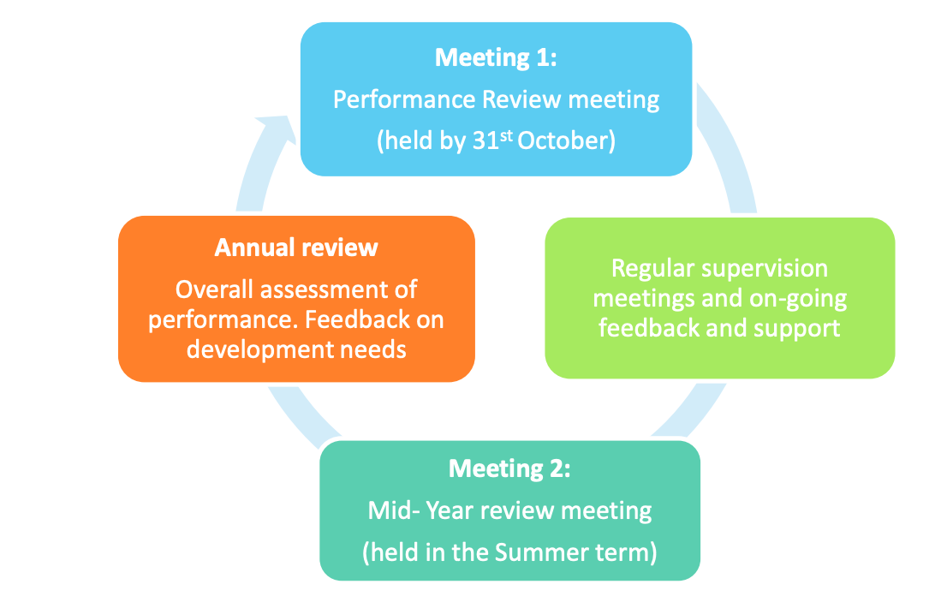

At the beginning of the autumn term, the Head Teacher will determine the standards against which all staff will be assessed. Staff will be made aware of the standards and at which level they should be performing. All Teachers will be evaluated against the ‘Teachers’ Standards’ published in July 2011 and Effective from September 1st 2021 (See Appendix 1). The following standards may also be used if relevant:
- National Head Teacher Standards (2004);
- National Standards for Subject Leaders (1998);
- SENCo Standards;
- Draft National Standards for School Leaders;
- School Leadership Standards;
- National occupational standards for supporting teaching and learning in schools.
All support staff with be evaluated against the duties set out in their job description and classroom-based support staff should also adhere to the Professional Standards for Teaching Assistants 2016 (see Appendix 1)
The responsibility for ensuring a productive discussion takes place at an appraisal meeting rests equally with the appraiser and appraisee. Detailed and considered preparation will often determine the success of the discussion.
Therefore, before the meeting appraisers should:
- Ensure the appraisal is conducted within agreed timescales;
- Organise a mutually convenient time and date (giving sufficient notice);
- Ensure enough time is allocated for the meeting and the environment is appropriate;
- Take time to effectively prepare for the discussion;
- Give the appraisee time to prepare.
In readiness for the appraisal, both the appraiser and appraisee should:
- Review previous appraisal paperwork;
- Consider performance against last year's objectives and evaluate whether they have been met or not;
- Reflect on areas of good performance including the way in which they work as well as what has been achieved;
- Consider how any learning and development activities have impacted on their role/performance;
- Familiarise themself with the School Improvement Plan and other key plans which may impact on their role;
- Complete self-evaluation against the roles and responsibilities stated on the job description;
- Ensure that performance over the whole of the review period is taken into account and give examples/evidence of performance to support ratings;
- Consider whether there are areas for performance improvement and prepare potential development objectives for discussion for the appraisal meeting.
- Appraisee should provide appropriate evidence of progress against objectives.

5.Appraisal Meeting
Review of previous objectives and targets ( Autumn Term)

Appraisers and appraisees should discuss previously set objectives and targets and provide evidence of achievement and comment on whether the objectives were met, partly met or not met. The outcome of the discussion should be recorded on the appraisal form.
It is appropriate to consider:
- Were there any barriers preventing completion outside of your control? If so, what were they?
- If the objective was achieved, how successful was it? (i.e. was it achieved to the standards expected or did it exceed expectations, etc?)
Objective setting (Autumn Term)

Staff will have objectives set which not only reflect their individual priorities within their role, but also contributes to the school’s plan for improving the school’s educational provision and performance.
Under normal circumstances staff will have a maximum of 3 objectives (attainment and progress, relevant standards according to your job role and professional development). However, employees who are found not to be meeting standards at the appropriate level for their career stage may be given additional objectives (as required) to ensure that the most appropriate support can be provided.
A fourth objective will be agreed between appraisers and appraises if deemed appropriate by both parties, or if the member of staff in question is paid on a Leadership Scale/ Upper Pay Scale or has a TLR.
Leadership and Management Objectives (where appropriate)

The performance of all Teachers with paid leadership responsibilities will be assessed against the relevant leadership standards and their impact on relevant school improvement priorities. Where no standards currently exist the Head Teacher will develop appropriate standards for these roles by reference to the draft national standards produced by the NCSL. Leadership and management objectives should be set to address any development priorities identified.

Professional Development Objectives (Spring Term)
(Review of Standards)
At the appraisal meeting, appraisers and appraisees should:
- Discuss the progress in line with each of the objectives. Appraisers will use the following terms: met, partially met and not met;
- For each objective, make a note of strengths/achievements and agree any areas for development;
- Where there are differences in ratings discuss the reasons for these and agree on a final rating;
- Discuss and agree professional development objectives in relation to the standards;
- In the event of not being able to reach agreement, the appraiser should record the rating which in their judgement corresponds to the level of performance demonstrated. The teacher may record their comments in writing as an appendix to the appraisal form.

6.Completion of the Appraisal

It is the responsibility of the appraiser to complete the appraisal statement and forward it to the appraisee for comment/approval within a reasonable time after the appraisal meeting. At this point, the appraisee can add any comments they wish to make in the relevant section of the form.
Once both parties are in agreement with the content, they should both sign and retain copies. The Governing Body and Head Teacher will ensure that all written appraisal records are retained in a secure place for six years and then destroyed.
The appraisal form will include the following:
- Details of the objectives for the appraisal period in question:
- An assessment of the employees performance of their role and responsibilities against their objectives and the relevant standards;
- An assessment of the teacher’s training and development needs and identification of any action that should be taken to address them;
- A recommendation on pay where that is relevant;
- Identified support for the forthcoming appraisal period.
A recommendation regarding pay will be considered by the Head Teacher who will refer it to the Local Governing Body, after which the outcome must be confirmed with the member of staff.

7.Ongoing review of performance

The level and nature of ongoing assessment required will be confirmed within the appraisal meeting and statement. It will be carried out in a supportive fashion and reflect the performance and development needs of the individual. Any feedback on performance will be given promptly and highlight particular areas of strength as well as any areas that need attention and will determine any appropriate action required. The Head Teacher and SLT have a duty to monitor standards of teaching and learning and the ongoing process will be reflected in the culture of the school.

Observation

Observations of classroom and leadership practice is important, both as a way of assessing performance in order to identify any particular strengths and areas for development, and of gaining useful information which can inform school improvement more generally. All observations will be carried out in a supportive fashion.
Employees’ performance will be regularly observed but the amount and type of classroom observation will depend on the individual circumstances of the member of staff and the overall needs of the school. This will be up to three hours but may be increased if there are concerns about performance (see 10 below).
Classroom observation will be also be carried out. In addition to formal observation, the Head Teacher or other leaders with responsibility for teaching standards may ‘drop in’ in order to evaluate the standards of teaching and to check that high standards of professional performance are established and maintained. The length and frequency of ‘drop in’ observations will vary depending on specific circumstances. Teachers (including the Head Teacher) and other members of staff who have responsibilities outside the classroom, should also expect to have their performance of those responsibilities observed and assessed.
Other means of assessing performance may include (but are not limited to):
- Planning and work scrutiny;
- Termly meeting with appraiser;
- Mid-cycle review meeting with appraiser;
- Observation / scrutiny of leadership and management activities where appropriate;
- Other feedback obtained during the cycle relevant to the employees overall performance;
- Focussed and moderated work with specific groups;
- Learning walks;
- Student behaviour and their management;
- Quality of learning environment;
- Lesson plans;
- Attainment and progress data;
- Book scrutiny.

8.Feedback

Employees will receive constructive feedback on their performance throughout the year and as soon as practicable after observation has taken place or other evidence has come to light. Feedback will include discussion with the member of staff and will highlight particular areas of strength, as well as any areas that need attention and will determine any appropriate action required.
9.Pay Progression
Where Teachers are eligible for pay progression, the recommendation made by the appraiser will be based on the assessment of their performance against the agreed objectives.
10.Transition to Capability
Where there are concerns about an employee’s performance, the employee’s progress will continue to be monitored as part of the performance management process and a reasonable time given for the employee’s performance to improve. During this period the employee will be given clear target(s), regular feedback on progress and appropriate support will be provided. At the end of that specified period, progress against those target(s) would be assessed, which could lead to an extension of the period or to an invitation to a transition meeting (the meeting to set up the informal stage of the capability process), which will be confirmed in writing.
If, on review, the required improvement has been made, the employee will be informed of this.
10.Confidentiality and Quality Assurance
The performance management and capability processes will be treated with confidentiality. However, the desire for confidentiality does not override the need for the Head Teacher to quality assure the operation and effectiveness of the appraisal system.
11.Monitoring and Evaluation
The Local Governing Body will monitor the operation and outcomes of performance management arrangements.
12. Linked Policies

This policy should be read in conjunction with the Capability Policy, Disciplinary Policy, Teaching and Learning Policy, Feedback and Marking Policy, Assessment Policy, and Behaviour Policy.

James Cambell Primary Performance Management Policy

Appendices

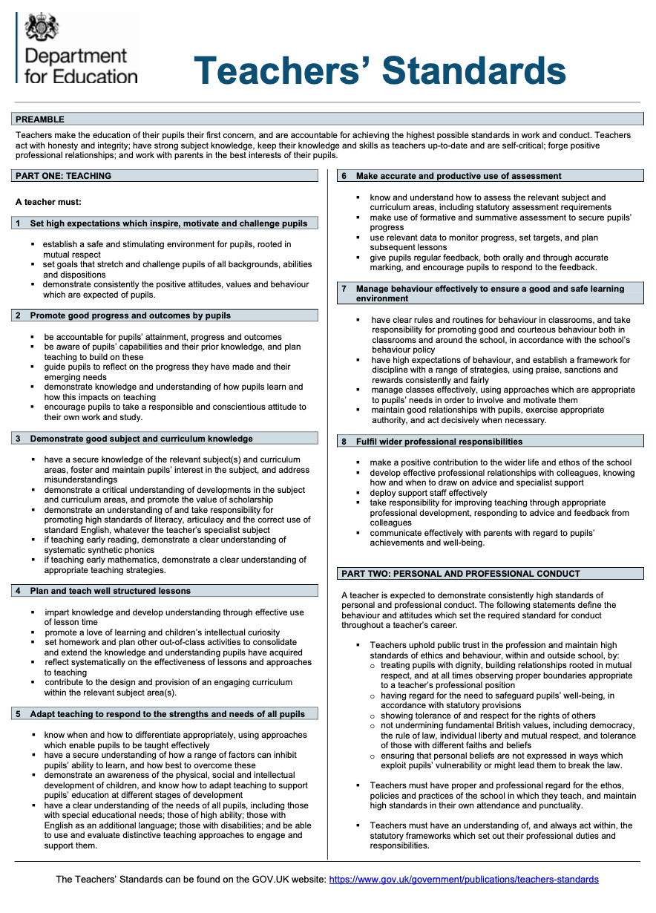
APPENDIX 1: Teachers Standards & Teaching Assistant Standards

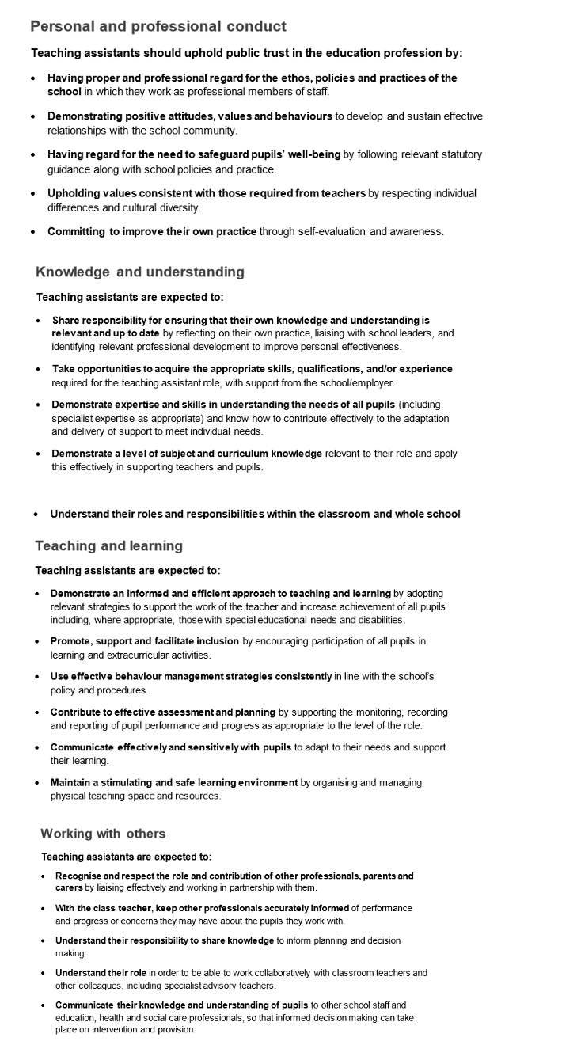
APPENDIX 2: Teacher Performance Management Proforma

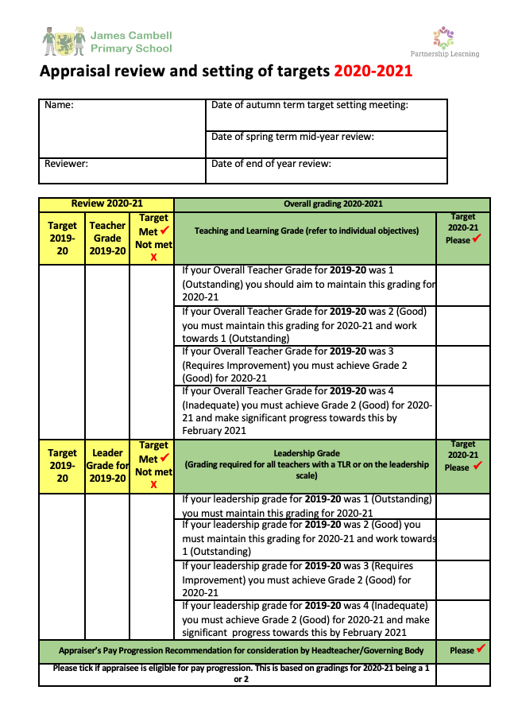

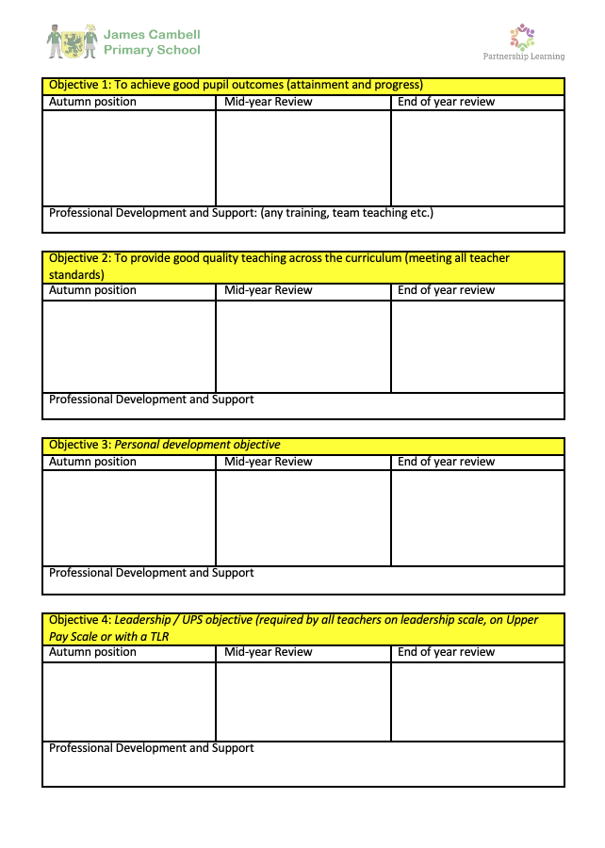

APPENDIX 2: Non- Teaching Staff Performance Management Proforma

