[](https://lbbd.sharepoint.com/sites/IntTp)

***LBBD Prevent Parent guide***

s

**How are young people radicalised?**

Young people may come into contact with adults and peers with extremist views both online and in everyday life. The person may be a friend or relative or may be a stranger they meet online.

Contact online may be through social media such as Facebook, Twitter or YouTube but young people may be invited to join discussions on less well-known sites such as Kik, Whisper, Messenger, Yik Yak or Telegram. Extremists often use these sites because they are harder to monitor and they can hide their identity. Extremists often manipulate young people by using emotional triggers to engage with them, and may target them when they are experiencing difficulties such as bereavement, emotional trauma, mental health issues or social isolation.

**Why do young people become radicalised?**

The reasons for young people being drawn into extremist views are many and varied but may include the following:

* They are trying to make sense of world events.
* They feel that their culture or religion is under threat.
* It makes them feel a sense of identity or belonging or

being part of something.

* They are looking for adventure or excitement.
* They have a personal grievance or experience of racism or discrimination and feel they want to change things.
* They are under pressure from their peers who have links with these groups.

***Extremism***- Vocal or active opposition to fundamental British values such as democracy, the rule of law and tolerance of different faiths and beliefs.

***Terrorism*** - A violent action against people or property, designed to create fear and advance a political, religious or ideological cause.

***Radicalisation*** - The process by which a person comes to support extremism and terrorism.

**Key terms**

Extremist groups use the internet and social media to spread their ideology and recruit vulnerable young people. They know young people are using the internet much more, quite often by themselves, and so utilise these opportunities to exploit and recruit. There is a chance that your child may meet people online or visit websites that could lead them to adopting what is considered extreme views, and become radicalised. Whether you’d like to protect your child from being radicalised or you are concerned that they may be at risk, navigate our guidance below to get expert tips on practical ways you can support them and where you can go for further support.

**How can parents keep young people safe?**

* Make sure you know where your child is and who they are with; find out about your child’s friends and their families.
* Be aware of your child’s **online activity** and check which social media sites they are visiting; report any sites that you have concerns about.
* Talk to your child about their lives and their interests; encourage them to take up **positive activities** with local groups that you trust.
* Help your child to be **critically aware** of what they see on the TV or the internet; encourage them to see different points of view and help them to develop tolerance for others.
* Remind your child that people they contact over the internet may not be telling them the whole truth and may not inform them of any potential dangers. **If they are being asked to keep something secret then they may be at risk of harm.**
* Get help from other members of your family or community that your child looks up to.

**Tackling the issue: a step by step guide**







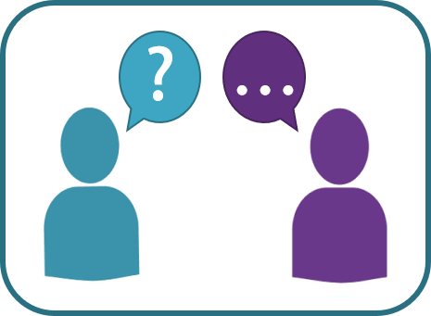

1. **Choose a news story**: this could be one your child is interested in, or one that you would like to discuss with them. Ask them how they feel about the story – one way to do this is by using Emotion cards like the ones below.

|  |  |  |
| --- | --- | --- |
| **How does this make you feel?** | | |
| **Confused** | **Curious** | **Calm** |
| **Angry** | **Anxious** | **Indifferent** |
| **Interested** | **Excited** | **Something else** |

1. **Research it together:** This could be from a source you have found or one your child has chosen or both! Consider these questions when looking at the resources:

* Who wrote it? Are they reliable and what evidence do they have?
* When was it written? Is the information up to date?
* Why was it written? Is there an agenda? Does the author have a bias?
* Where else can you check the information?

1. **Talk about it:** Share what you have found and discuss your reaction to it. Have your initial thoughts and judgements changed? Engaging in this process and showing you are willing is crucial. This will reassure your child that they can have these conversations with you.

* Educate against hate - <https://educateagainsthate.com/>
* ThinkUKnow - <https://www.thinkuknow.co.uk/parents/>
* NSPCC Talking to children about terrorism - <https://www.nspcc.org.uk/keeping-children-safe/reporting-abuse/dedicated-helplines/protecting-children-from-radicalisation/>
* Parentzone - <https://www.parents.parentzone.org.uk/>
* Ineqe Safeguarding group - <https://ineqe.com/safeguarding-hub/>
* BBC Newsround - <https://www.bbc.co.uk/newsround>
* Simple Politics - <https://www.simplepolitics.co.uk/>

**Where else can I find support?**

**What can I do if I have a concern?**

If you are worried about your child or have concerns that your child may be being radicalised then you can contact:

* Your childs’ school by speaking to their teacher or the Designated safeguarding lead
* Your local Prevent team by emailing [prevent@lbbd.gov.uk](mailto:prevent@lbbd.gov.uk)

All the professionals will work together with you and your child to see what support can be offered to protect your child against radicalisation and the risks associated with it.