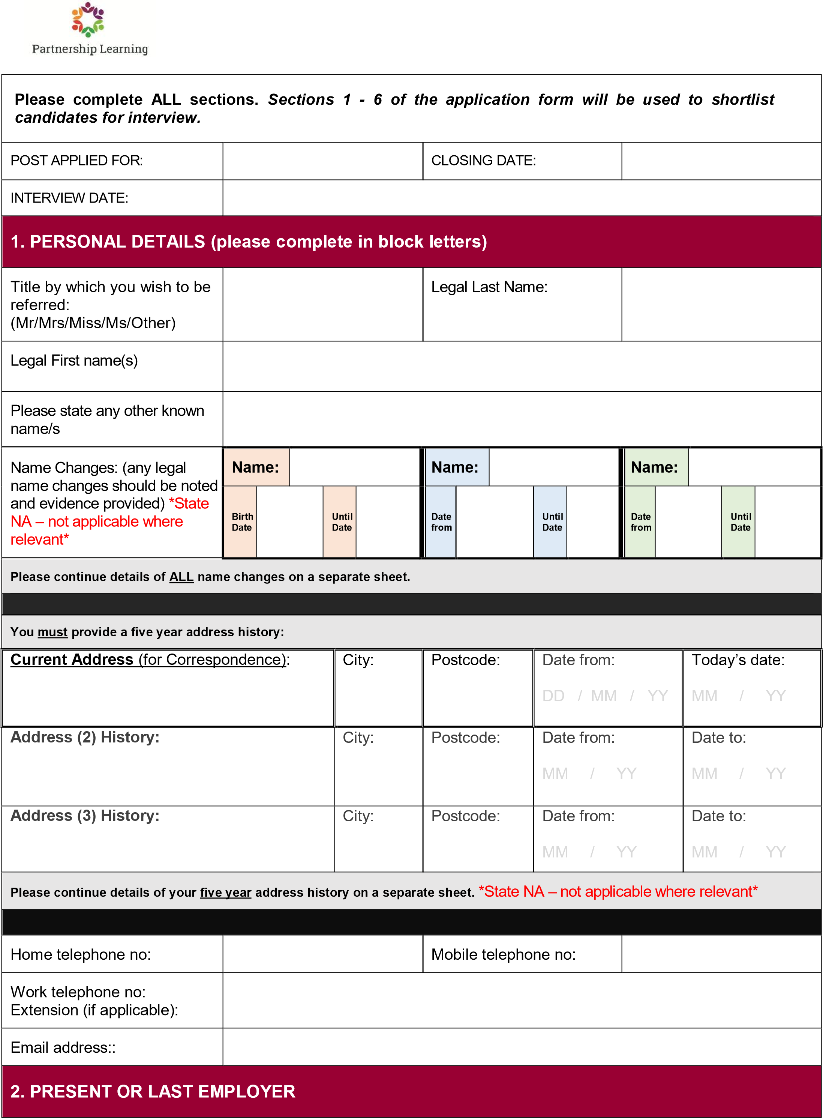

Do you have CONTINUOUS SERVICE: YES / NO (please circle)
Name and address of employer: |  |  |  | Name and address of establishment where employed (if different):
Postcode: |  |  |  | Postcode:
Nature of business: |  |  |  | Job title:
Present annual salary or weekly income (gross):
Hours worked per week: |  |  |  | Other benefits (if applicable):
Date appointed: |  |  |  | Notice required or leaving date if already left
Reason for leaving:
Brief description of duties:
3. PREVIOUS EMPLOYMENT
Start with the most recent first.
Include work/voluntary experience and also indicate any periods of unemployment/not in employment, with details (using the job title and dates section). Do not leave any unexplained gaps in your employment history. (Please continue on separate sheet if necessary).
Employer name & address | Job title |  | Salary/income | Full or part-time (if part-time, give hours) | Dates  (month/year) |  |  | Reason for leaving
 |  |  |  |  | From | To

4. EDUCATION, TRAINING & QUALIFICATIONS
(Please continue on separate sheet if necessary). Please start with the most recent.
Secondary  School/College/University | Dates |  | Qualifications gained (state level) |  | Grade/class of degree | Date
 | From | To
OTHER RELEVANT TRAINING COURSES ATTENDED (Please continue on separate sheet if necessary)
Organising Body | Course title |  |  | Length of course
MEMBERSHIP OF PROFESSIONAL BODIES
Name of body | Type of membership |  |  | Date obtained
5. INFORMATION IN SUPPORT OF YOUR APPLICATION
Please give details of any relevant experience, skills or knowledge to support your application. Be concise but make sure that you cover ALL the essential points of the person/employee specification.
NOTE; Your response to this section is extremely important and will be the basis of the short-listing panel's decision to invite you for interview.
6. REFEREES
Please provide details of two referees below. Friends and relatives are NOT acceptable referees. One of the referees must be your present/or most recent employer and normally no offer of employment will be made without reference to

him/her. If you have not previously been employed, then Head Teachers, College Lecturers, or other persons who are able to comment authoritatively on your educational background and/or personal qualities, are acceptable as referees.
The Trust reserves the right to approach any previous employer or manager. Where references are received prior to interview, an opportunity will be given to discuss the content of references with the interviewing panel.
Name (Referee 1): |  | Name (Referee 2):
Title | Mr/Mrs/Miss/Ms/other | Title | Mr/Mrs/Miss/Ms/other
Role: |  | Role:
Organisation (if appropriate): |  | Organisation (if appropriate):
Address: |  | Address:
Postcode: |  | Postcode:
Telephone No: |  | Telephone No:
Email address: |  | Email address:
How long known? |  | How long known?
Do you give consent to us contacting your present employer prior to interview? |  | YES NO
7. Disclosure and Barring and Childcare disqualification
The James Cambell Primary School and Partnership Learning is legally obligated to process a Disclosure and Barring Service (DBS) check before making appointments to relevant posts. The DBS check will reveal both spent and unspent convictions, cautions, and bind-overs as well as pending prosecutions, which are not “protected” under the Rehabilitation of Offenders Act 1974 (Exceptions) Order 1975.
We will use the DBS check to ensure we comply with the Childcare Disqualification Regulations. Any data processed as part of the DBS check will be processed in accordance with Data Protection regulations and The James Cambell Primary School/Partnership Learning privacy statement.
If you have lived or worked outside of the UK in the last 5 years the James Cambell Primary School/Partnership Learning may require additional information in order to comply with ‘safer recruitment’ requirements. If you answer ‘yes’ to the question below, we may contact you for additional information in due course.
Have you lived or worked outside of the UK in the last 5 years?: YES 󠇊 No 󠇊
8. Right to work in the UK

The James Cambell Primary School/Partnership Learning will require you to provide evidence of your right to work in the UK in accordance with Immigration, Asylum, and Nationality Act 2006.
By signing this application, you agree to provide such evidence when requested.
9. GENERAL
Please give details of any dates within the next [2 months] when you will not be available for interview. We cannot guarantee being able to offer you an alternative date.
Do you hold a current full driving licence? | YES NO
Do you have regular use of a vehicle? | YES NO
You are required to declare below any relationship with or to an employee of the Trust.
Please state name and position:
Have you ever been the subject of formal disciplinary proceedings? If yes, please give details including dates below. | YES NO
This information is required, including that related to warnings regarded as "spent" in order to ensure safe recruitment and meet our obligations to safeguard children. However, you should be aware that any disciplinary history declared will not automatically prevent or inhibit appointment and will depend on the dates and circumstances related to the disciplinary action, outcomes and the type of post being applied for. Note that you are also required to include information if you were subject to a disciplinary process but resigned before it was completed.
10. EQUALITY & REASONABLE ADJUSTMENTS
The Equality Act 2010 states a person has a disability if they have a physical or mental impairment which has a long-term and substantial adverse effect on their ability to carry out normal day-to-day activities. We will consider reasonable adjustments to enable disabled applicants to have equal access to employment opportunities via the selection process. We are committed to the development of positive practices to promote equality in employment. If you would like to declare your disability so that we can make reasonable adjustments to the selection process, please tick the appropriate box below.
Do you consider yourself to be disabled? | YES NO
Is there any information that we need in order to offer you a fair selection interview/process?
11. HEALTH/MEDICAL DETAILS
Successful applicants will be required to complete a confidential medical questionnaire and may be required to undergo a medical examination.
12. DATA PROTECTION ACT
The personal information collected on this form will be processed on computer to manage your application. If successful, your personal information will be retained whilst you are an employee and used for payroll, pension and employee administration. It will not ordinarily be disclosed to anyone outside the Trust without first seeking your permission, unless there is a statutory reason for doing so. We are under duty to protect the public funds that we administer and to this end may use the information you have provided on this form for the prevention and detection of fraud. It may also share this information with other bodies responsible for auditing or administering public funds for these purposes.
13. DECLARATION
If you return your application form to us by email and you are subsequently invited to interview, you will be required to sign a printed copy of your form.
I declare that, to the best of my knowledge and belief, the information given on ALL parts of this form is correct. I understand that, should my application be successful and it is discovered subsequently that information has been falsified, then disciplinary action may be taken which may include dismissal from the post.
I confirm that I have a legal right to work in the UK and if this application is successful, I undertake to produce appropriate documentary evidence to prove this, prior to commencing work with the Trust.
Signed | Date
Please return you completed form by email, post or by hand by the closing date to: office@jamescambellprimary.org.uk

